**AMERICAN INTERNATIONAL**

**UNIVERSITY-BANGLADESH**

**Faculty of Science and Technology**

**Assignment Cover Sheet**

|  |  |  |  |  |
| --- | --- | --- | --- | --- |
| Assignment Title: | **Automated Testing using Selenium** | | | |
| Assignment No: | 01 | | Date of Submission: | 19 March 2024 |
| Course Title: | Software Quality and Testing | | | |
| Course Code: | CSC4721 | | Section: | B |
| Semester: | Spring | 2023-24 | Course Teacher: | **Abhijit Bhowmik** |

**Declaration and Statement of Authorship:**

1. I/we hold a copy of this Assignment/Case-Study, which can be produced if the original is lost/damaged.
2. This Assignment/Case-Study is my/our original work and no part of it has been copied from any other student’s work or from any other source except where due acknowledgement is made.
3. No part of this Assignment/Case-Study has been written for me/us by any other person except where such collaboration has been authorized by the concerned teacher and is clearly acknowledged in the assignment.
4. I/we have not previously submitted or currently submitting this work for any other course/unit.
5. This work may be reproduced, communicated, compared and archived for the purpose of detecting plagiarism.
6. I/we give permission for a copy of my/our marked work to be retained by the Faculty for review and comparison, including review by external examiners.
7. I/we understand that Plagiarism is the presentation of the work, idea or creation of another person as though it is your own. It is a formofcheatingandisaveryseriousacademicoffencethatmayleadtoexpulsionfromtheUniversity. Plagiarized material can be drawn from, and presented in, written, graphic and visual form, including electronic data, and oral presentations. Plagiarism occurs when the origin of them arterial used is not appropriately cited.
8. I/we also understand that enabling plagiarism is the act of assisting or allowing another person to plagiarize or to copy my/our work.

*\* Student(s) must complete all details except the faculty use part.*

** Please submit all assignments to your course teacher or the office of the concerned teacher.

|  |  |
| --- | --- |
| Group Name/No.: |  |

|  |  |  |  |  |
| --- | --- | --- | --- | --- |
| **No** | **Name** | **ID** | **Program** | **Signature** |
| **1** | **Noshin Farzana** | **21-44647-1** | **BSc [CSE]** |  |
| **2** | **Avijit Saha Anto** | **21-44630-1** | **BSc [CSE]** |  |
| **3** | **Md Sanim** | **21-44606-1** | **BSc [CSE]** |  |
| 4 | **Arik Ahmed Zelan** | **21-44600-1** | **BSc [CSE]** |  |

|  |  |  |
| --- | --- | --- |
| ***Faculty use only*** | | |
| FACULTYCOMMENTS | **Marks Obtained** |  |
|  |
|  |
|  | **Total Marks** |  |

* **Automated Testing:** The testing conducted by machine or tools is called Automated Testing.

Here, “Selenium” tool is used for testing the features of our web-based project “Restaurant Management

System”.

There are 4-types of Users in our project. They are-

* Customer
* Admin
* Delivery Man
* Manager

|  |  |
| --- | --- |
| In this project the **“Customer”** has the following features:   * Registration * Login * Logout * Forgot Password * Update Profile * Update Password * Place Order * Search Items * Add to Cart, Remove from Cart * Confirm Order & See Total Bill * Notification (Order Progress, Delivery Man Information) * Order History * Give Reviews * File a Complaint to Admin | In this project the **“Admin”** has the following features:   * Login * Logout * Forgot Password * Update Profile * Update Password * View All Information (Customer, Delivery Man, Manager) * Recruit Manager * Ban Customer * Add/Delete/Update Menu * View All Customer Order List * Manage Resign Application * See Customer Complaints |
| In this project the **“Delivery Man”** has the following features:   * Login * Logout * Forgot Password * Update Profile * Update Password * Order Notification * See Order List & Take Order * Confirm Delivery * Delivery History & Earnings * Resign | In this project the **“Manager”** has the following features:   * Login * Logout * Forgot Password * Update Profile * Update Password * Recruit Delivery Man * View All Delivery Man * Overview of Total Revenue * Update Stock * Approve Customer Review |

* **Steps of Automated Testing using Selenium:**
* **Setup Selenium IDE**

First of all, Selenium IDE was downloaded, and the extension was added in the Chrome Browser. Then, logged into the Gmail account to start working on the IDE.

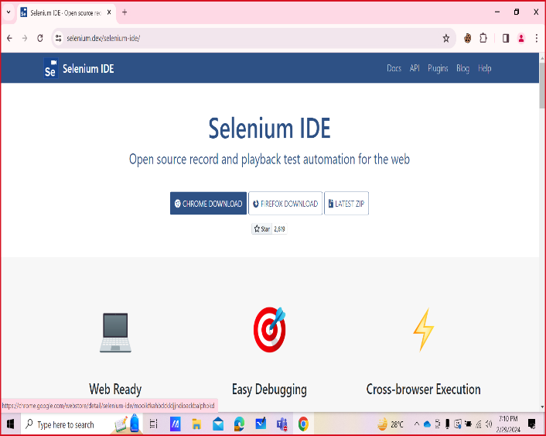

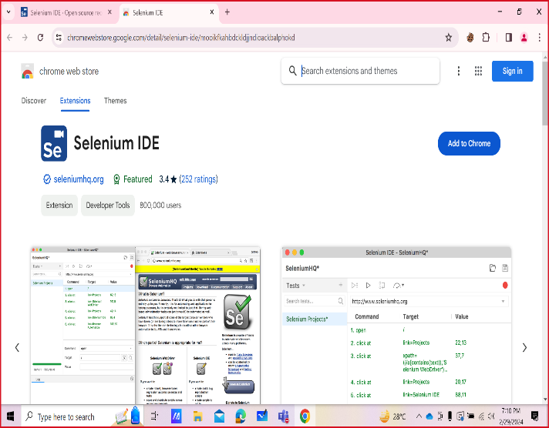

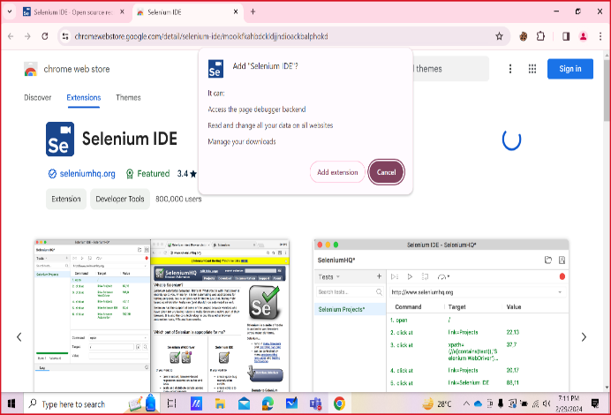

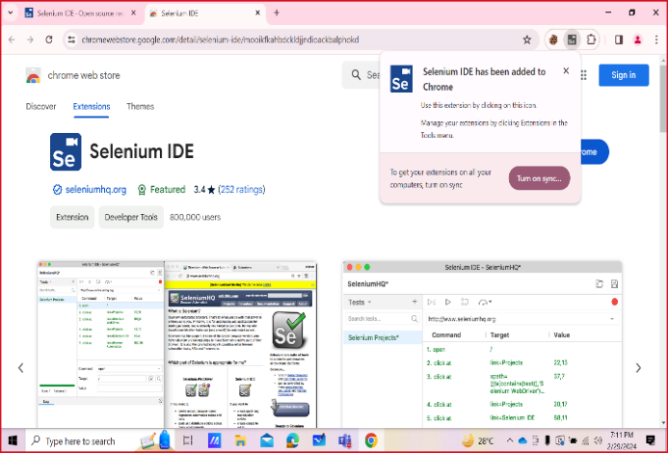

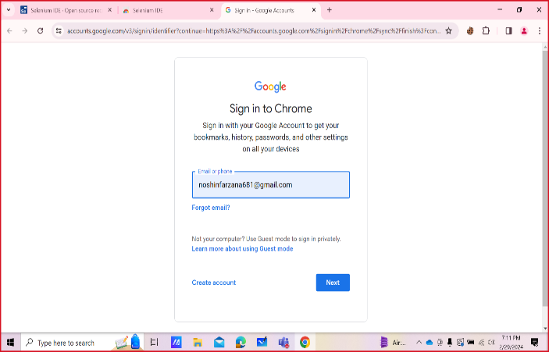

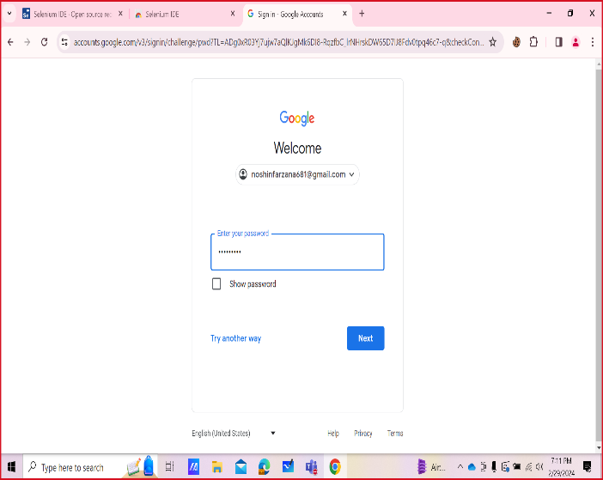

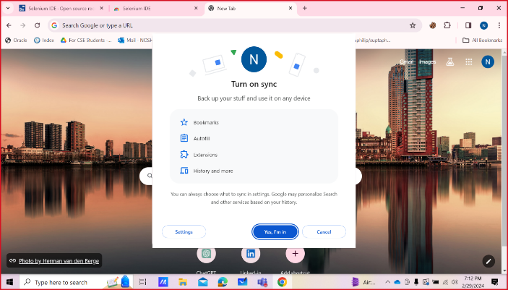

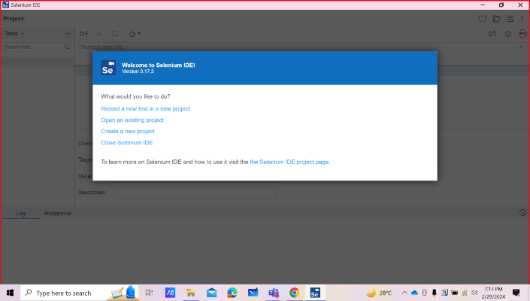

A project named “Restaurant Management System” was created in the Selenium IDE. Then, the project was run through the XAMMP Control Panel and the URL of it was provided in the Selenium IDE to record the activities during test.

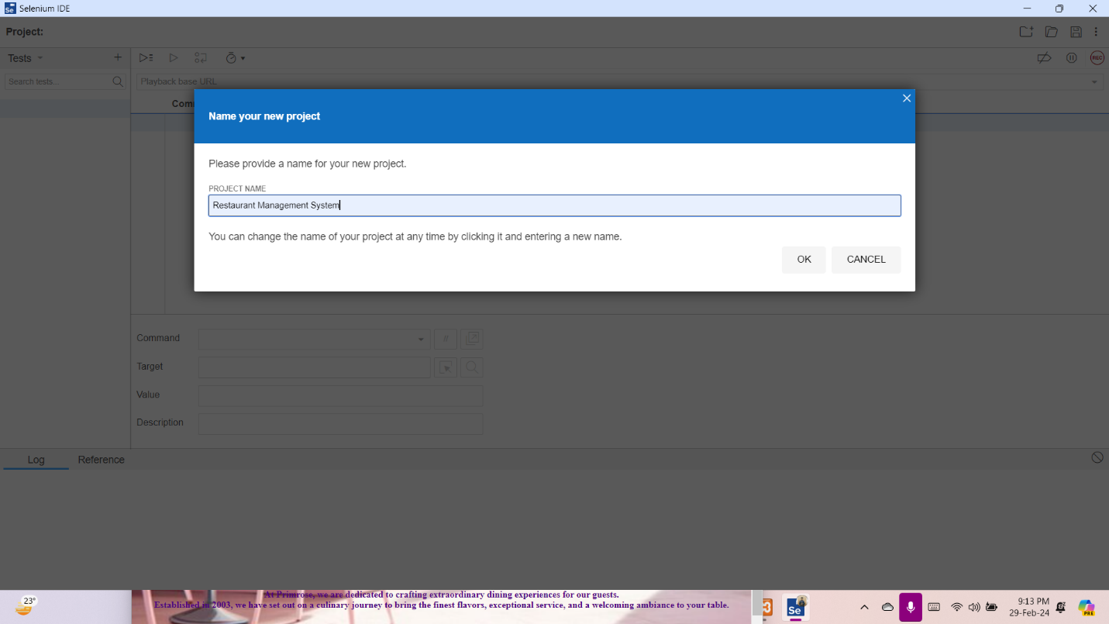

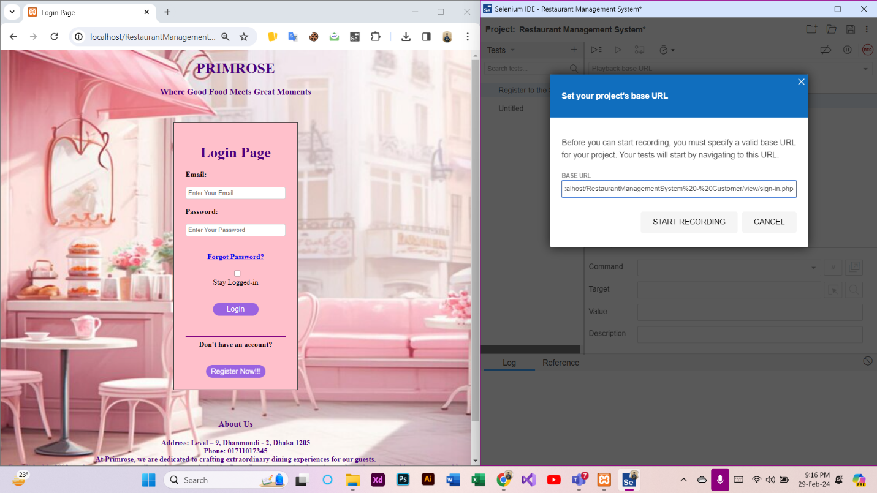

* **Run Test Cases**

Here, all the screenshots of testing steps performed in Selenium IDE are attached below-

**Test Case 1: Register to the System (Customer)**

At first, a new test case named “Register to the System” was added in the Selenium IDE. Then, REC button was clicked to provide the URL of the project and record the activities of Registration. After that, the Registration procedure was completed through the website. Finally, the recording was stopped and the test case was run successfully.

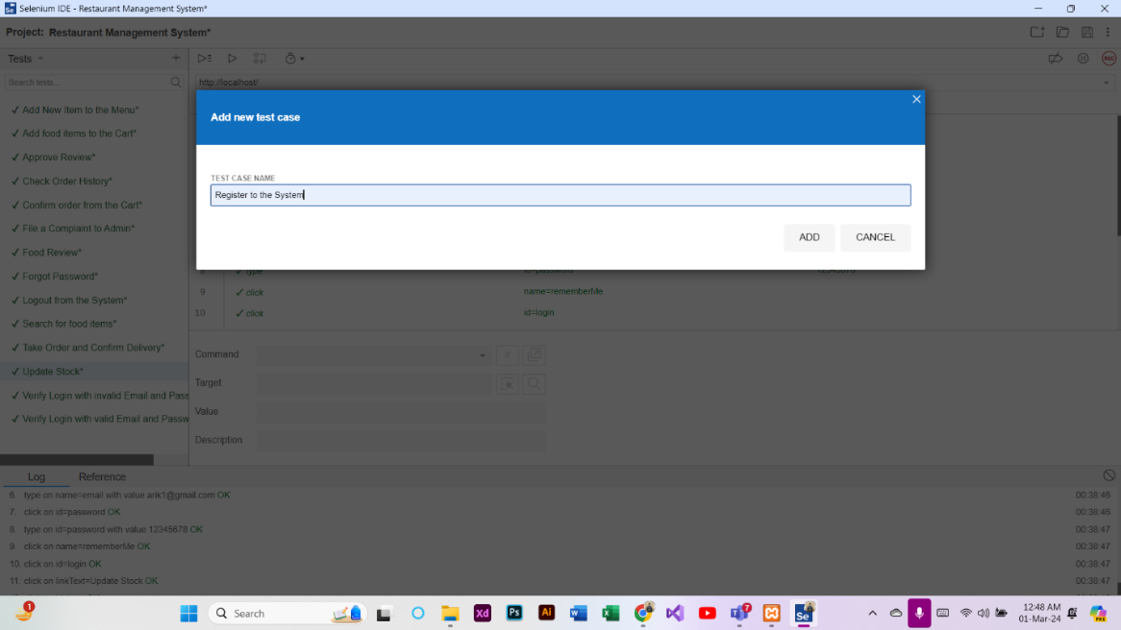

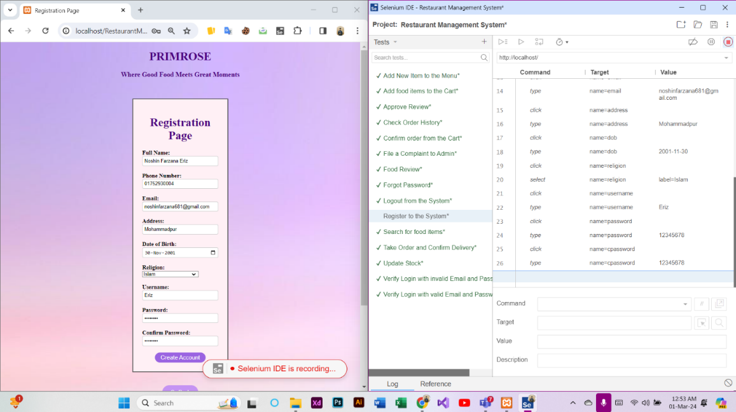

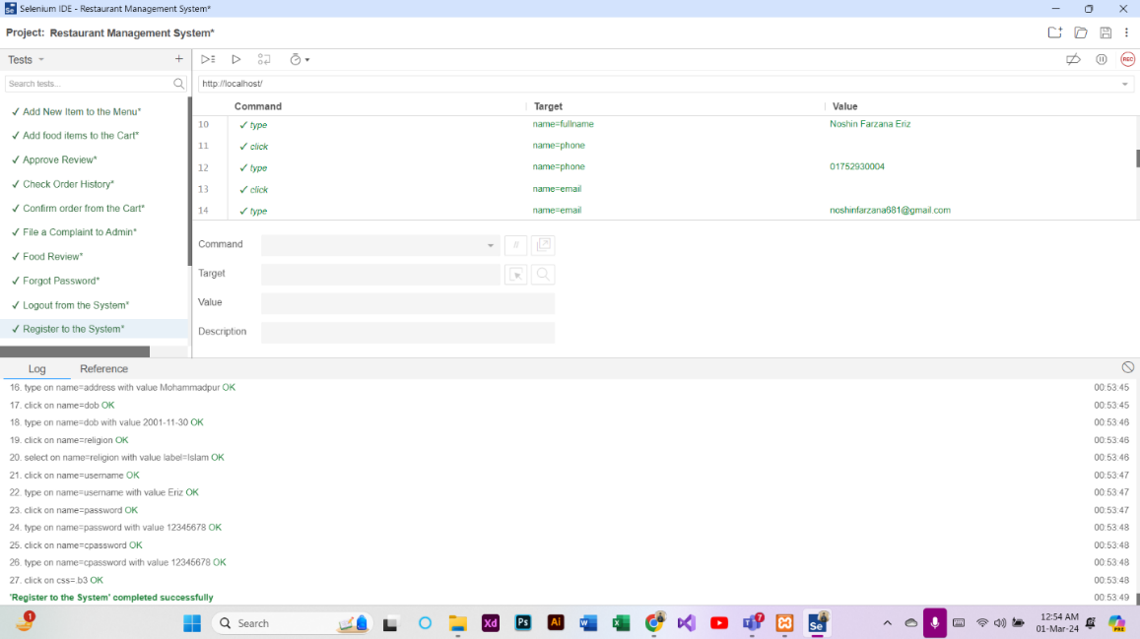

**Test Case 2: Verify Login with valid Email and Password (Customer)**

At first, a new test case named “Verify Login with valid Email and Password” was added in the Selenium IDE. Then, REC button was clicked to provide the URL of the project and record the activities of Login. After that, the Login procedure was completed through the website. Finally, the recording was stopped and the test case was run successfully.

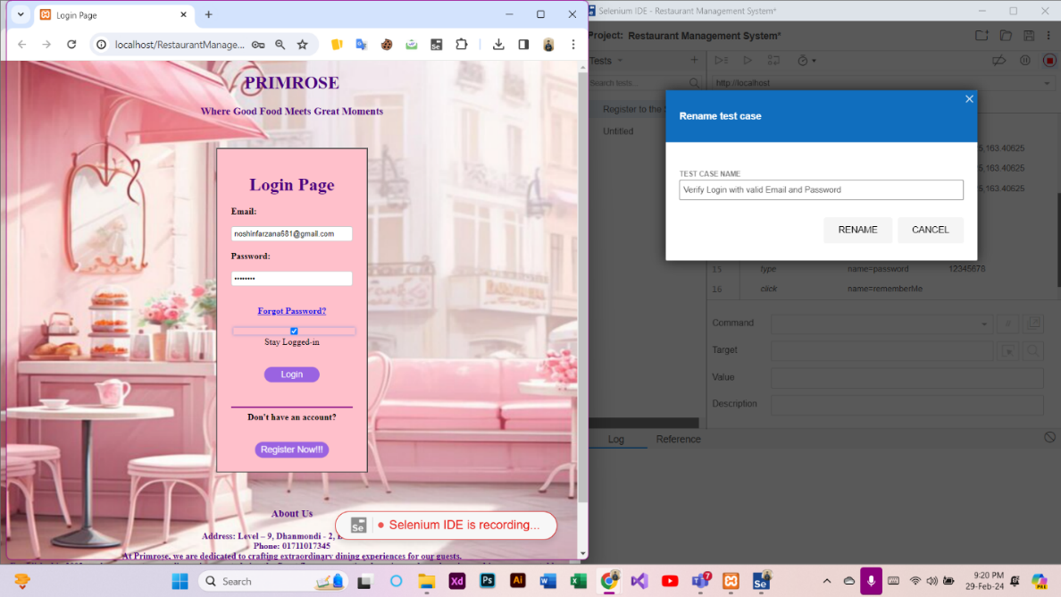

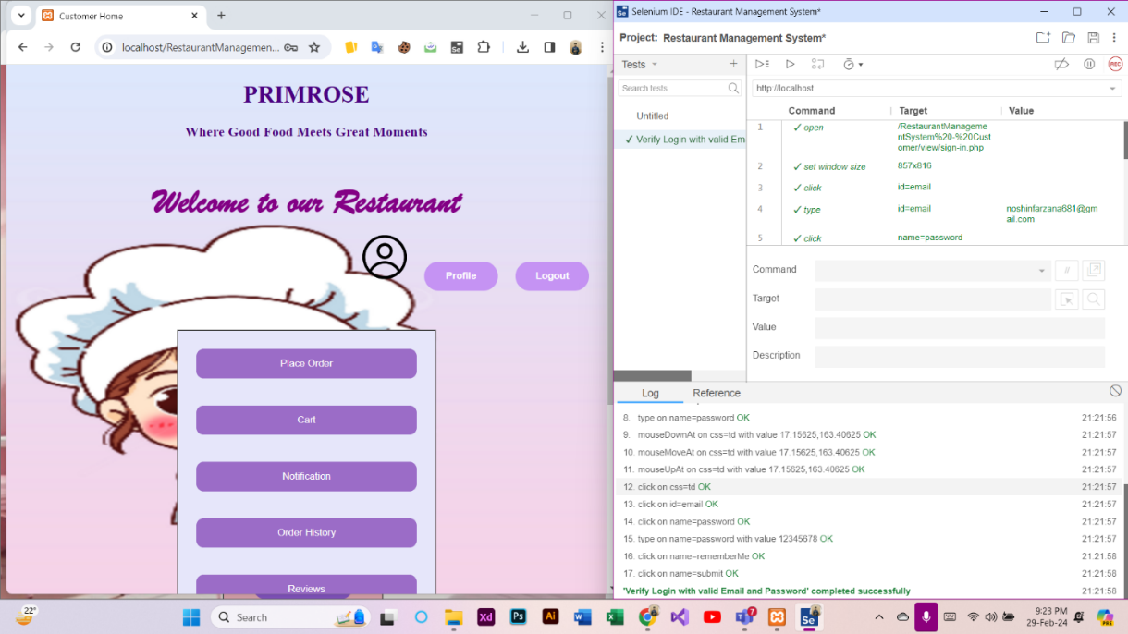

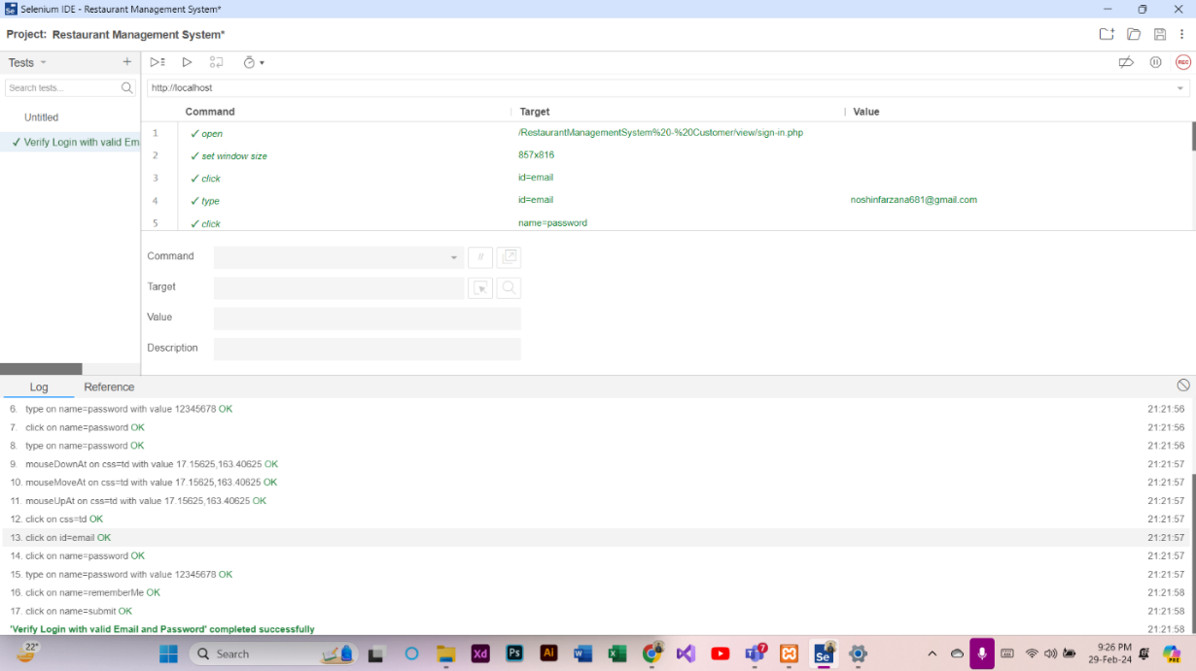

**Test Case 3: Verify Login with invalid Email and Password (Customer)**

At first, a new test case named “Verify Login with invalid Email and Password” was added in the Selenium IDE. Then, REC button was clicked to provide the URL of the project and record the activities of Login. After that, the Login was denied for providing invalid email and password. Finally, the recording was stopped and the test case was run successfully.

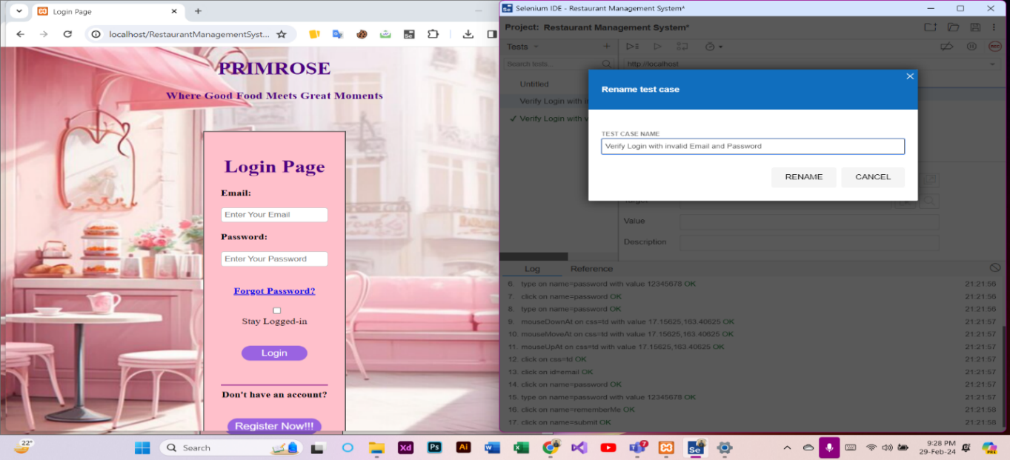

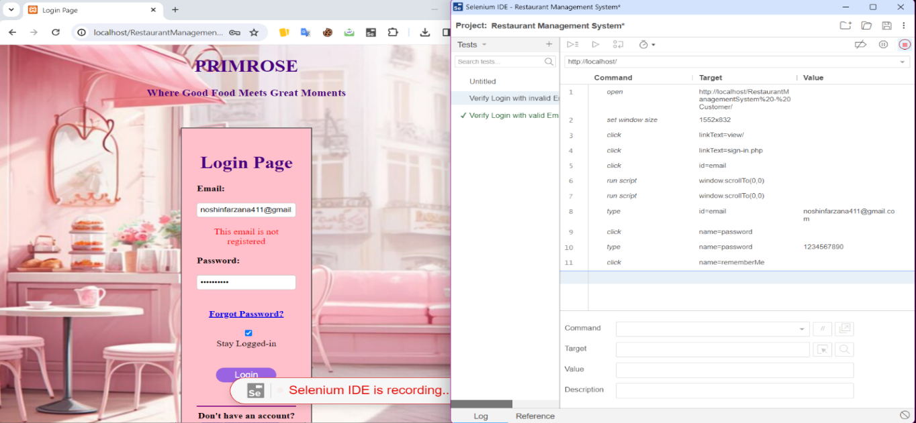

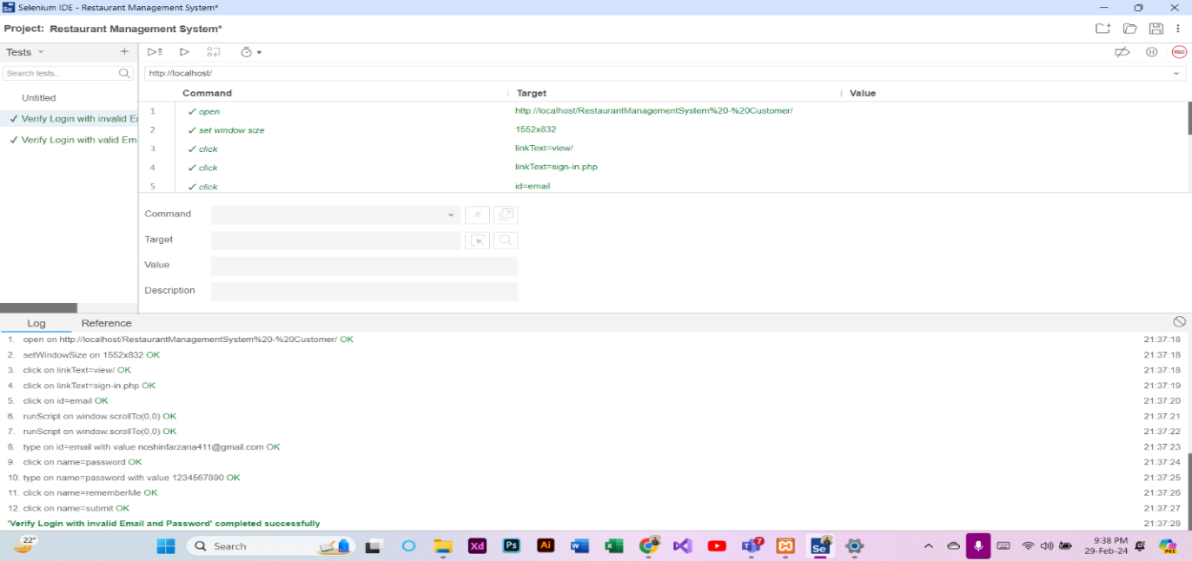

**Test Case 4: Logout from the System (Customer)**

At first, a new test case named “Logout from the System” was added in the Selenium IDE. Then, REC button was clicked to provide the URL of the project and record the activities of Logout. After that, the Logout procedure was completed through the website. Finally, the recording was stopped and the test case was run successfully.

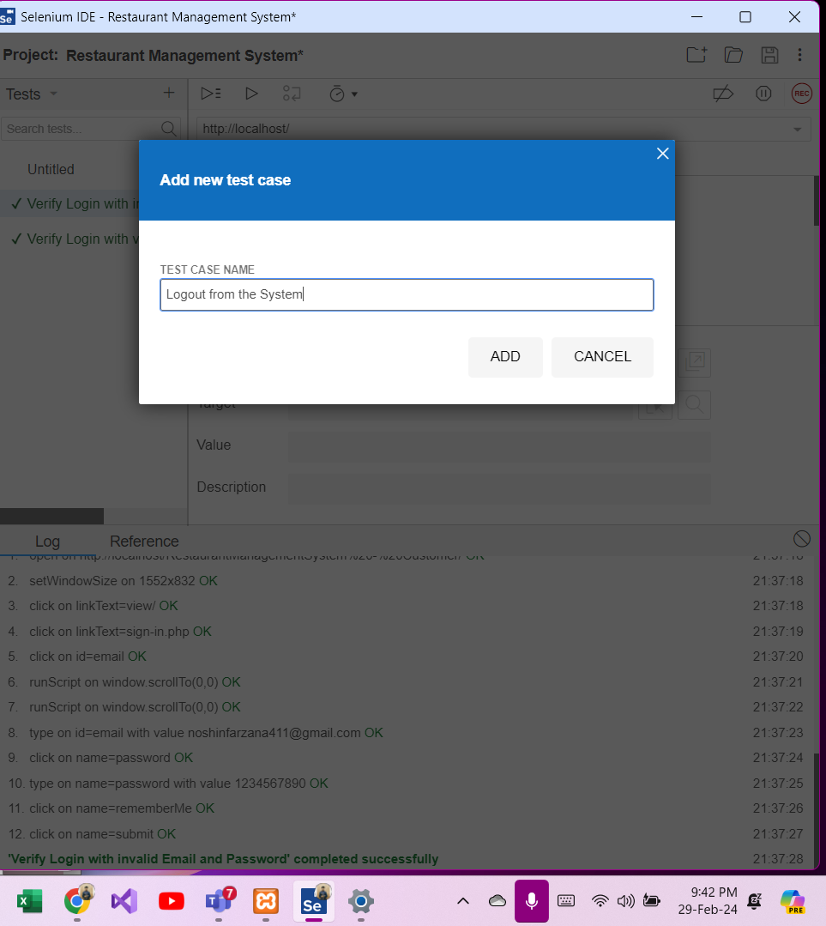



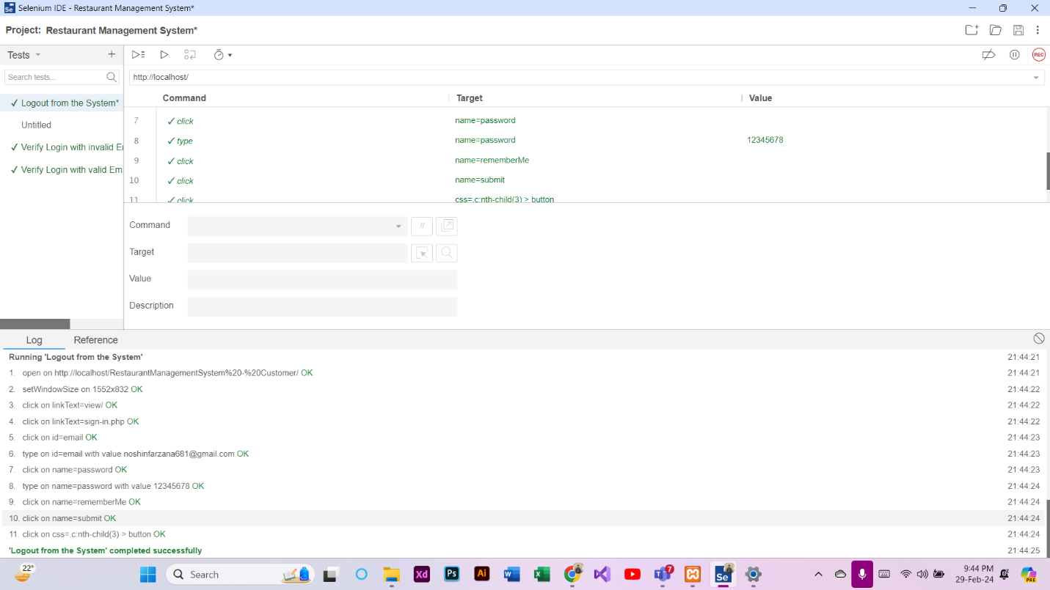

**Test Case 5: Forgot Password (Customer)**

At first, a new test case named “Forgot Password” was added in the Selenium IDE. Then, REC button was clicked to provide the URL of the project and record the activities of Forgot Password. After that, the Forgot Password procedure was completed through the website. Finally, the recording was stopped and the test case was run successfully.

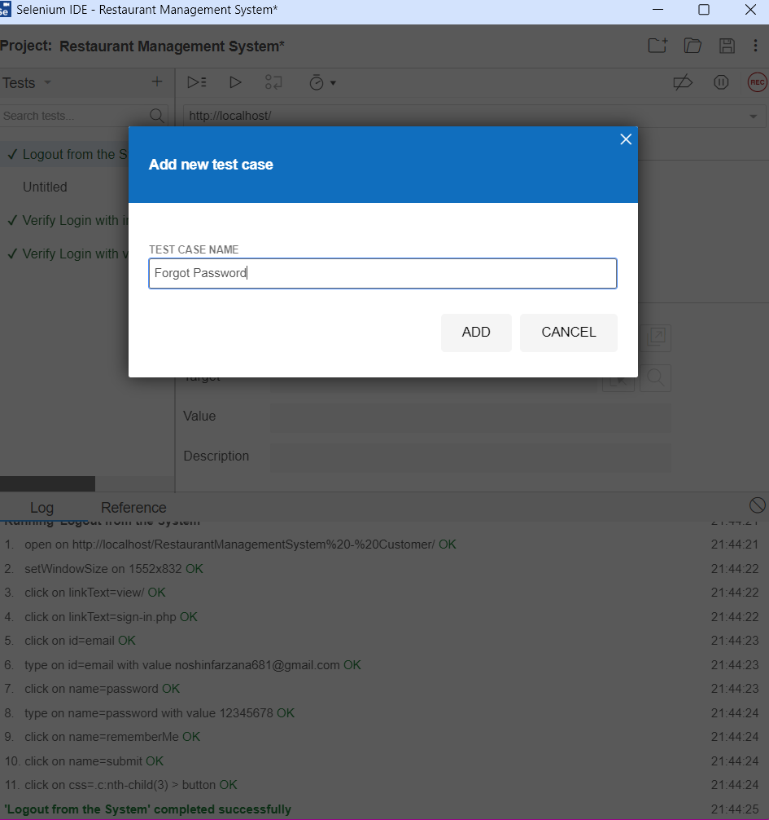

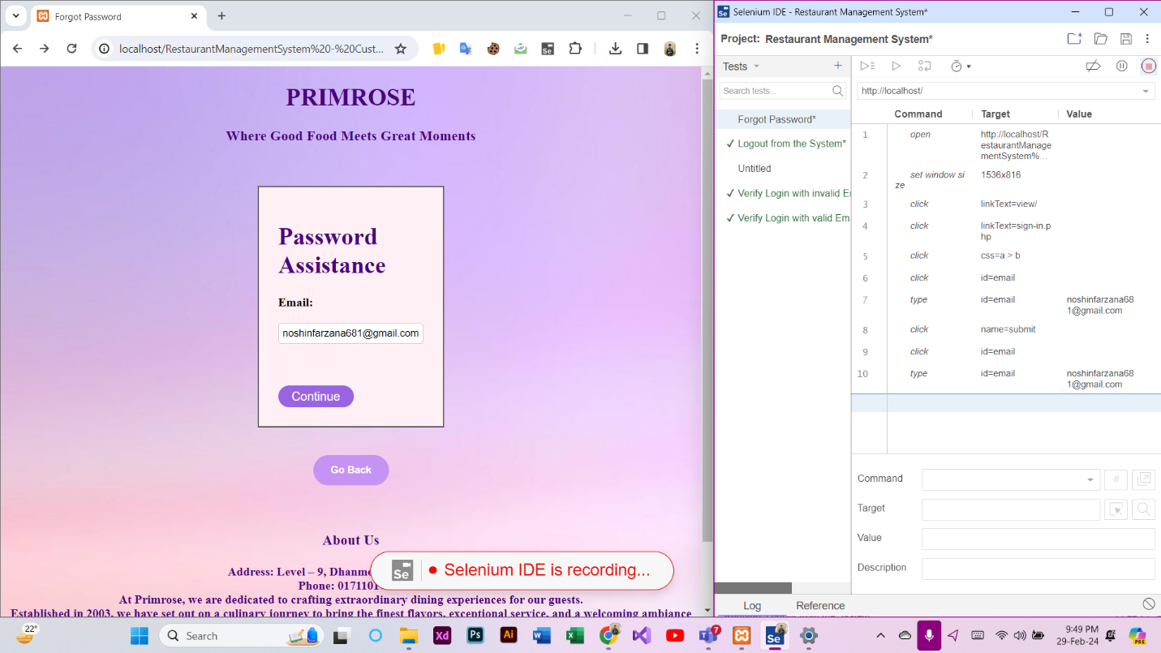

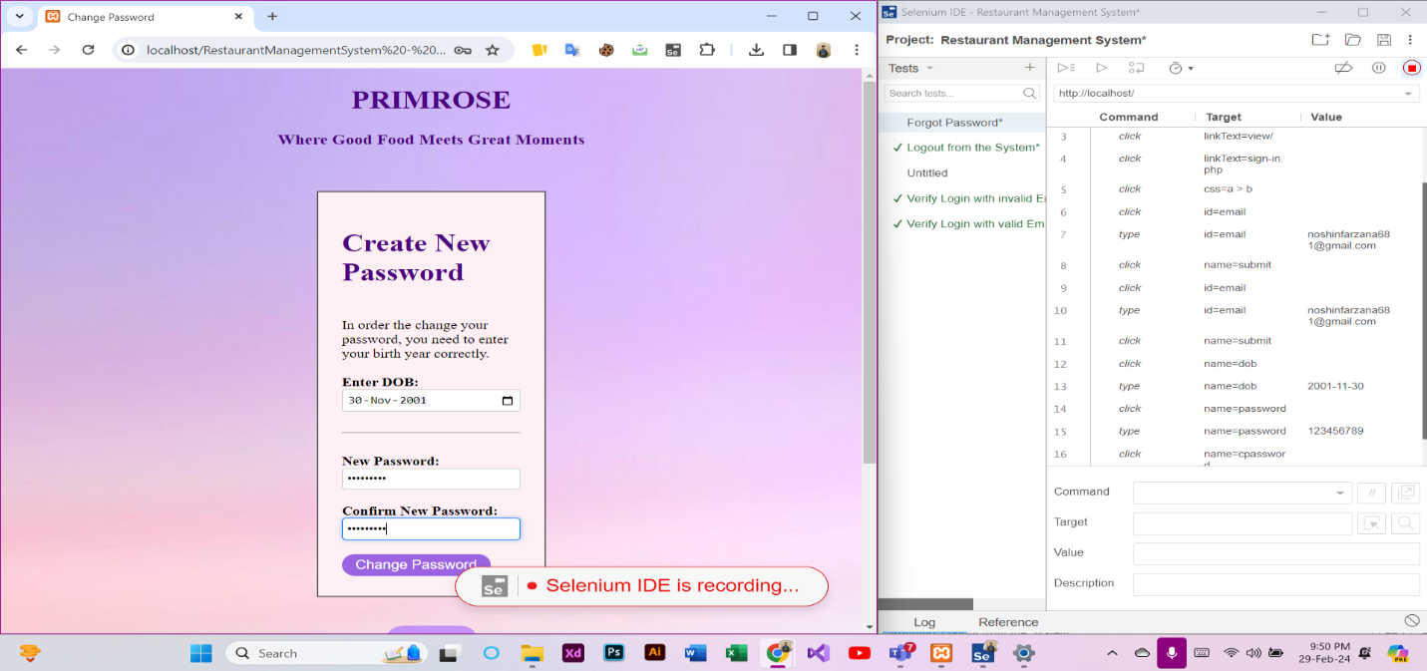

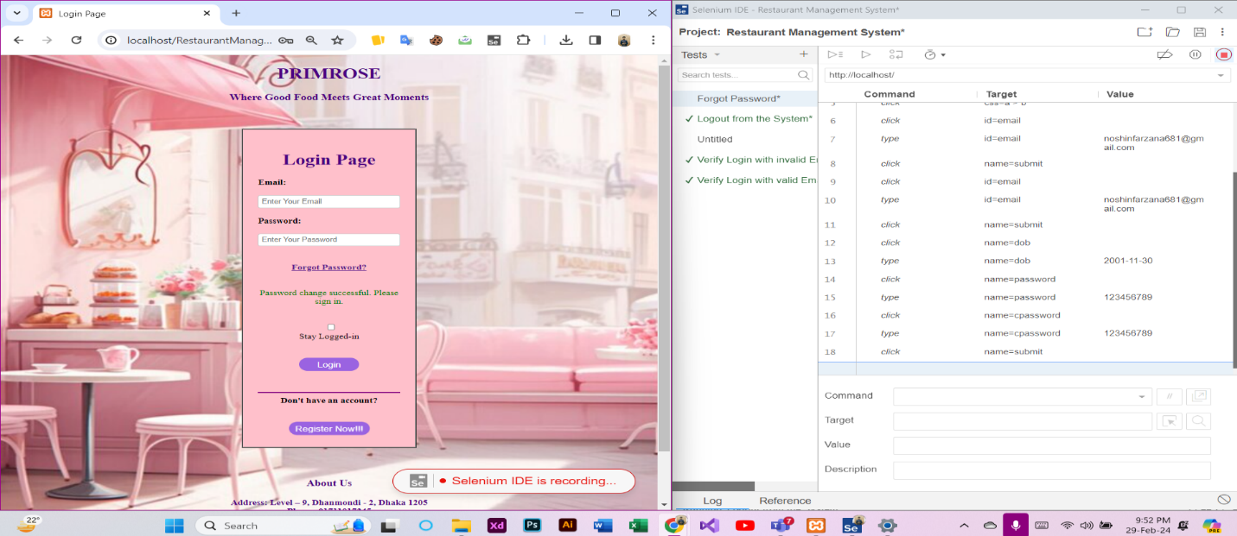

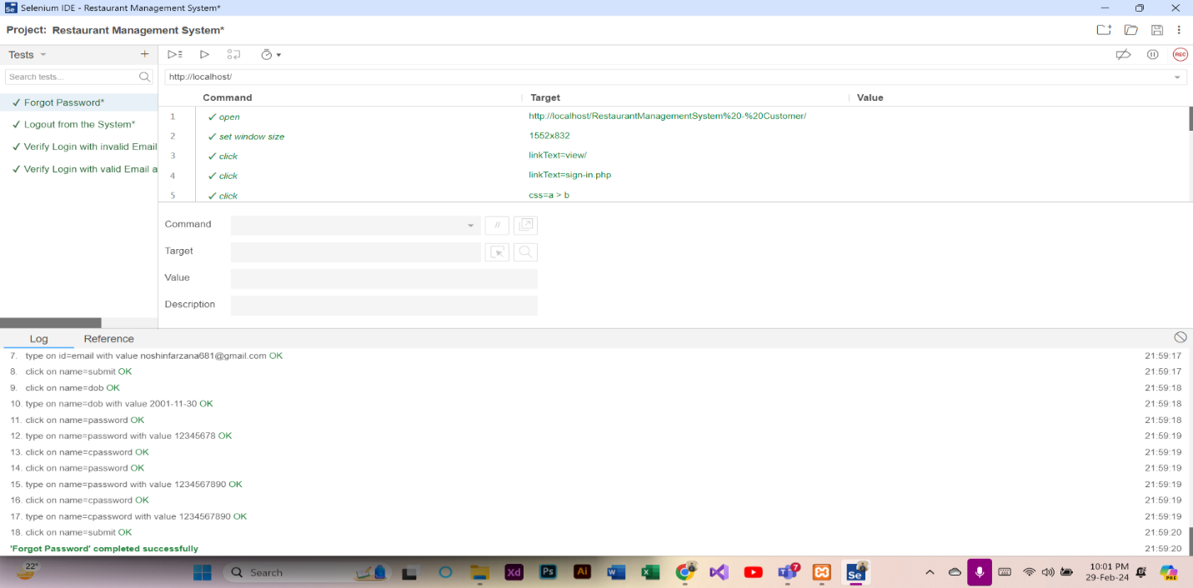

**Test Case 6: Edit and Update Profile (Customer)**

At first, a new test case named “Edit and Update Profile” was added in the Selenium IDE. Then, REC button was clicked to provide the URL of the project and record the activities of Profile Update . After that, the Edit and Update Profile procedure was completed through the website. Finally, the recording was stopped and the test case was run successfully.

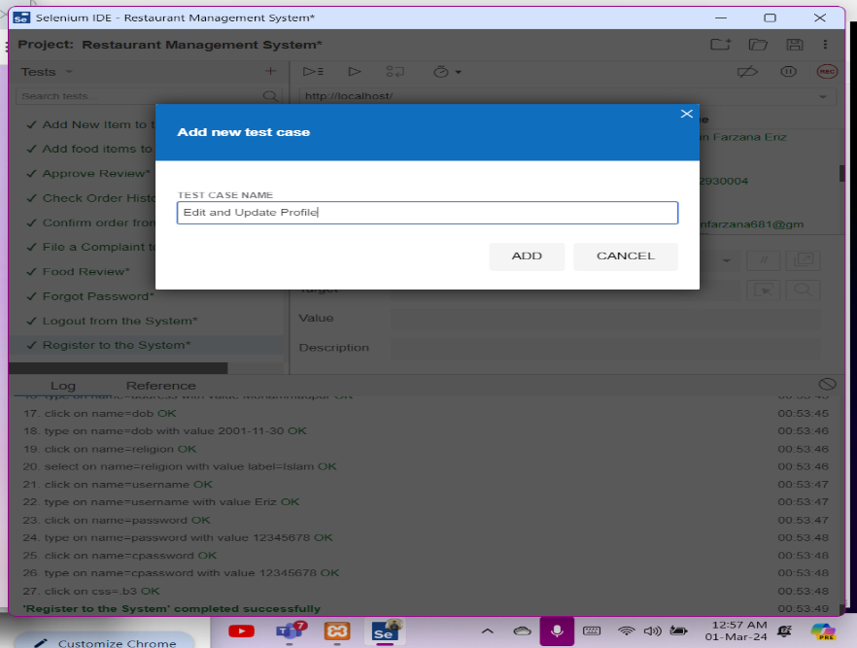

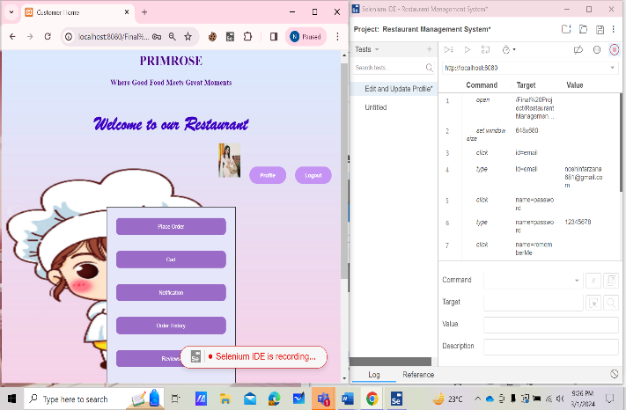 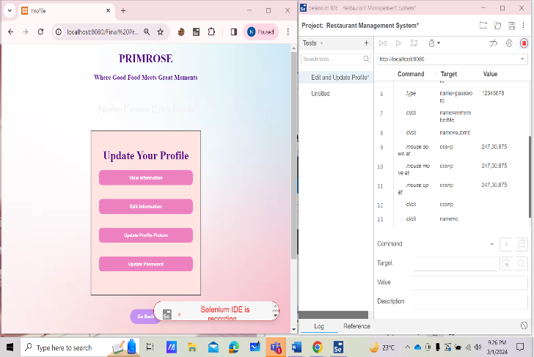

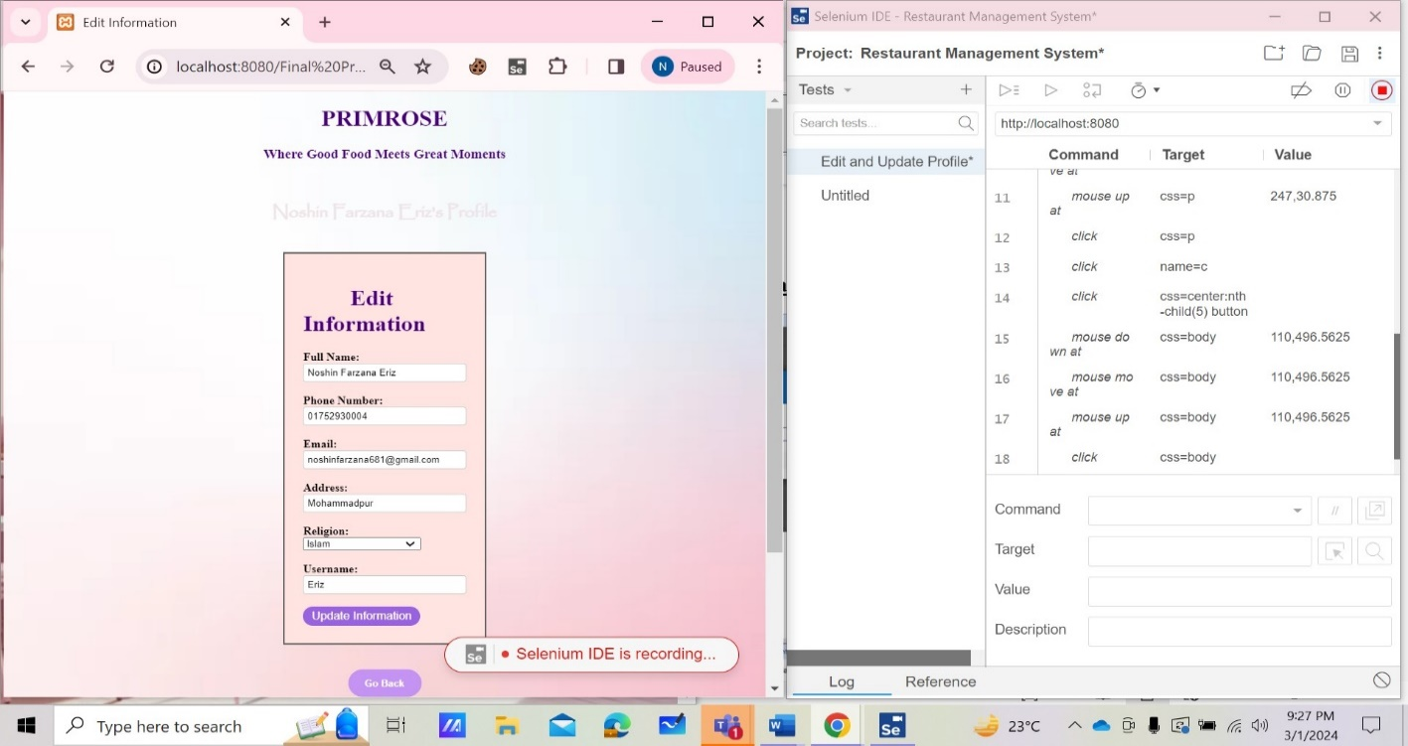

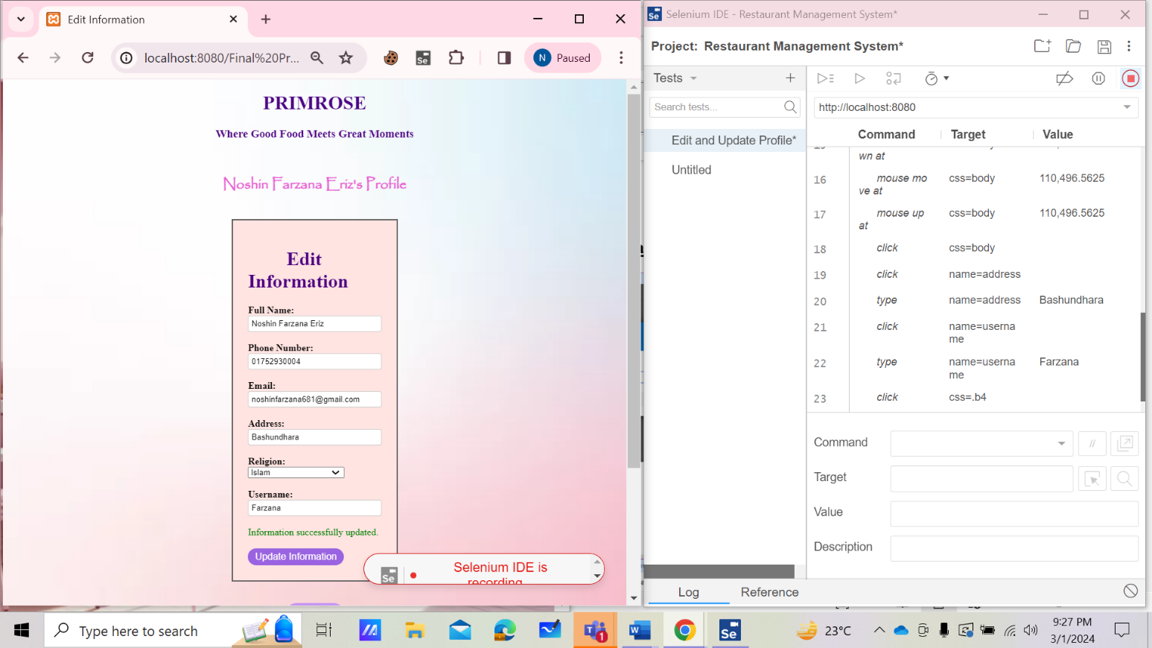

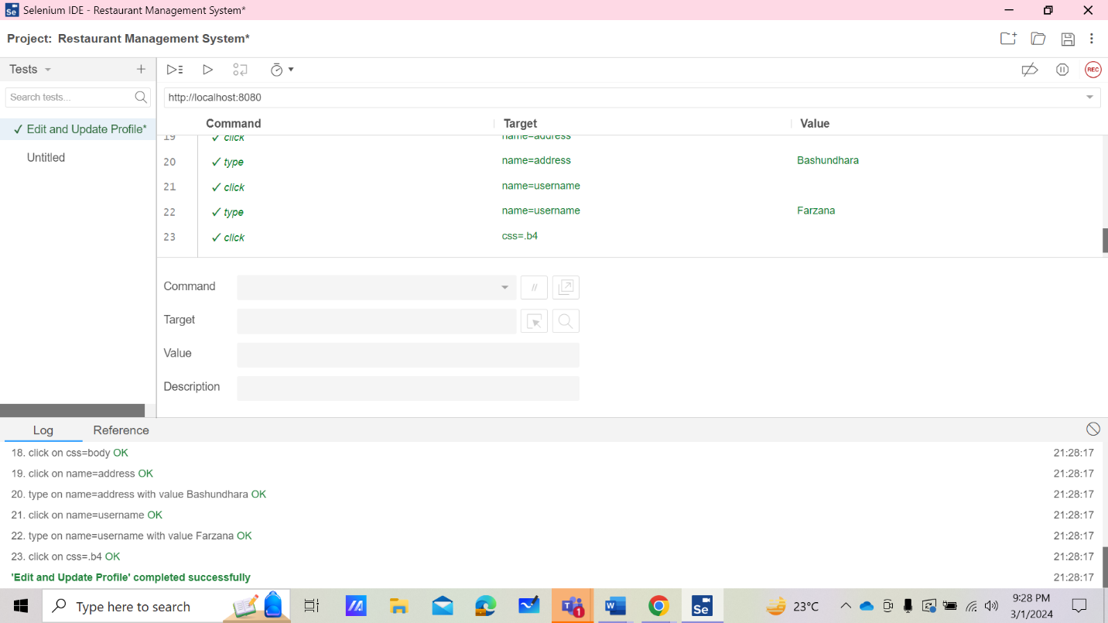

**Test Case 7: Search for food items (Customer)**

At first, a new test case named “Search for food items” was added in the Selenium IDE. Then, REC button was clicked to provide the URL of the project and record the searching activities. After that, the Search for food items procedure was completed through the website. Finally, the recording was stopped and the test case was run successfully.

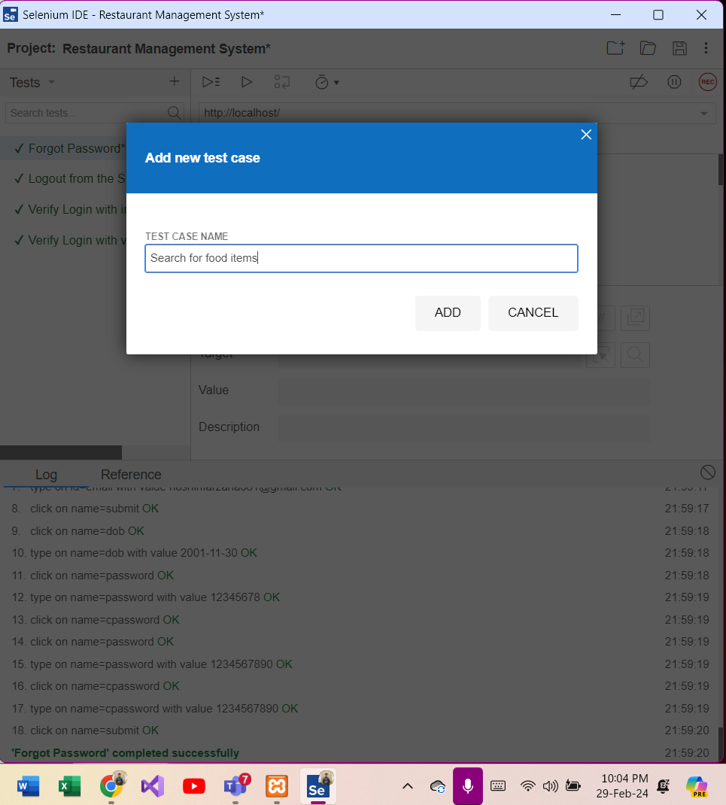

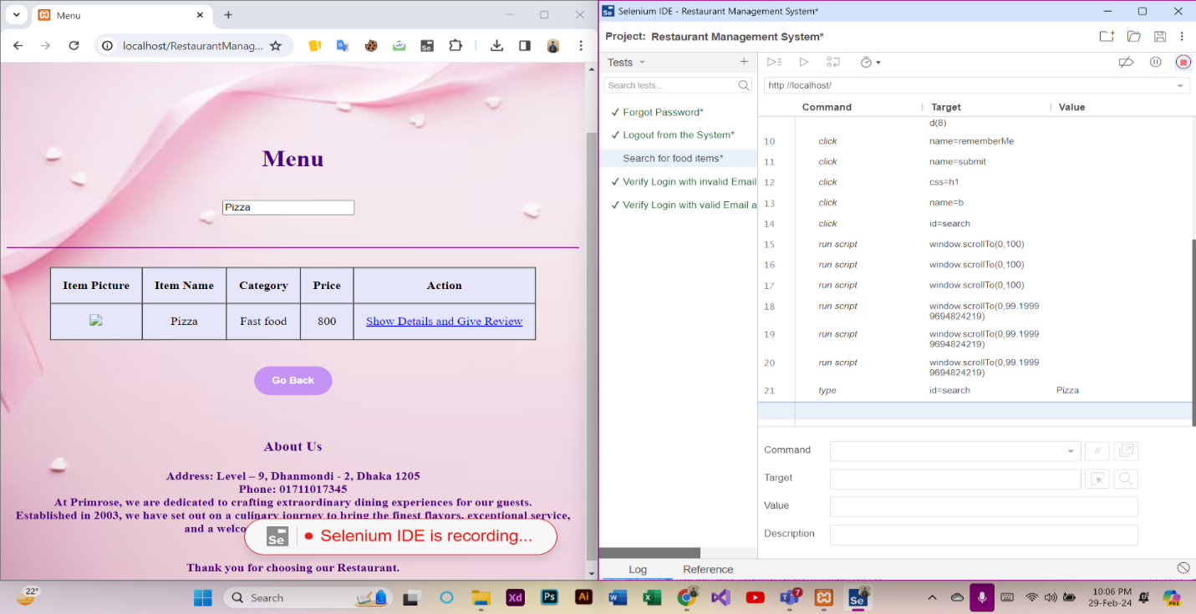

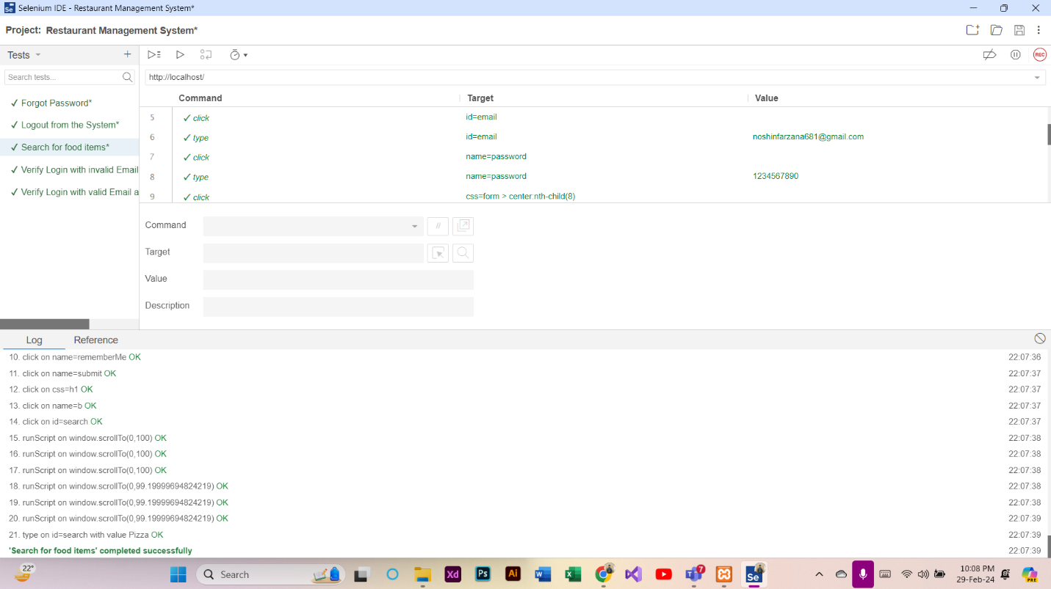

**Test Case 8: Add food items to the Cart (Customer)**

At first, a new test case named “Add food items to the Cart” was added in the Selenium IDE. Then, REC button was clicked to provide the URL of the project and record the activities of adding food items. After that, the Add food items to the Cart procedure was completed through the website. Finally, the recording was stopped and the test case was run successfully.

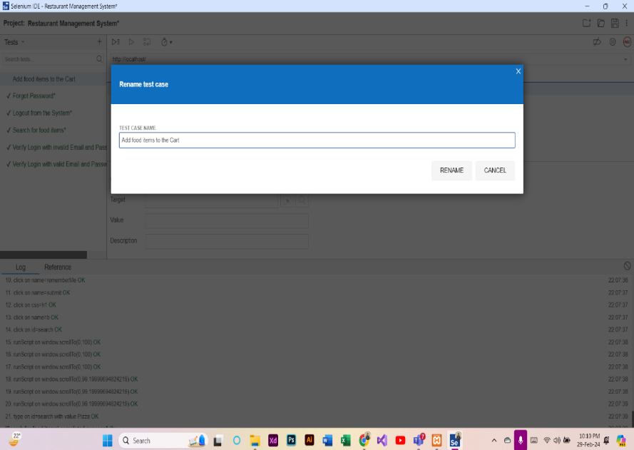

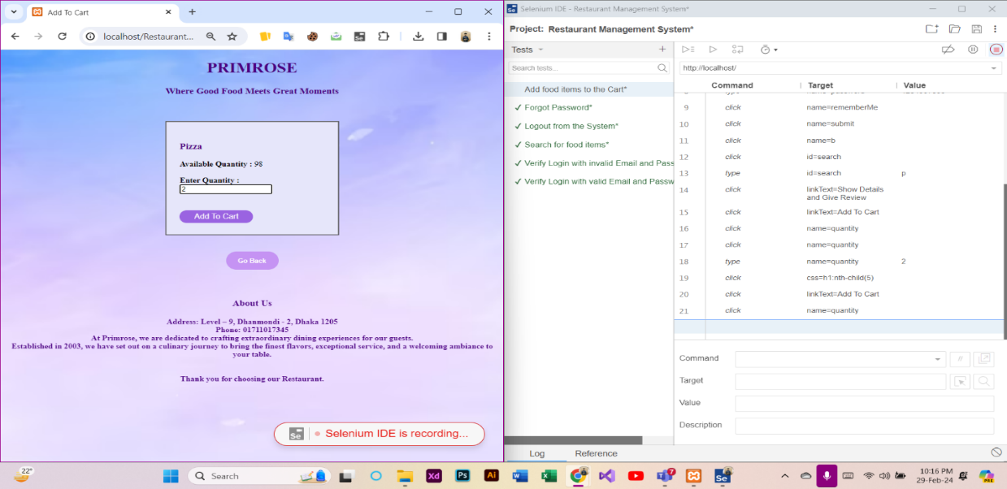

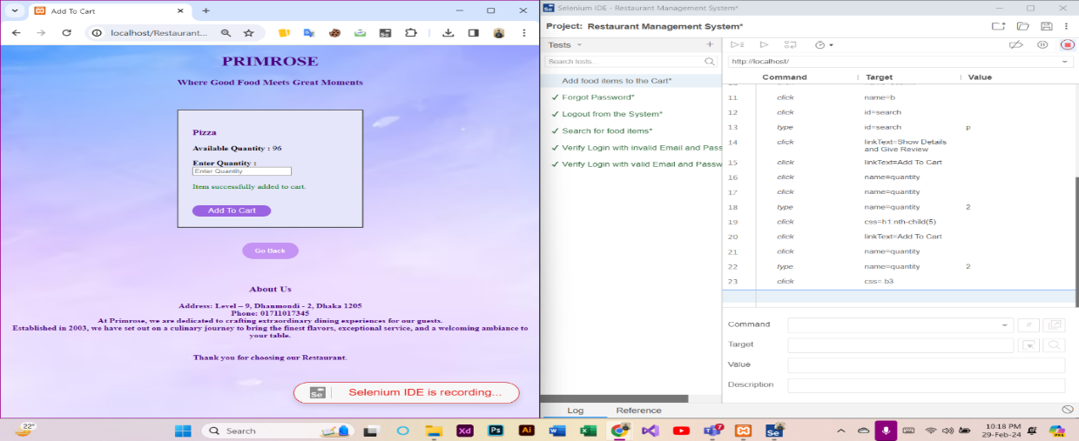

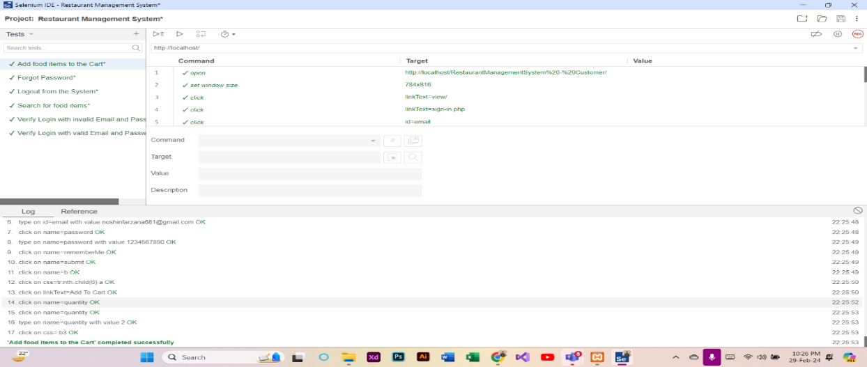

**Test Case 9: Confirm Order from the Cart (Customer)**

At first, a new test case named “Confirm Order from the Cart” was added in the Selenium IDE. Then, REC button was clicked to provide the URL of the project and record the activities of confirmation. After that, the Confirm Order from the Cart procedure was completed through the website. Finally, the recording was stopped and the test case was run successfully.

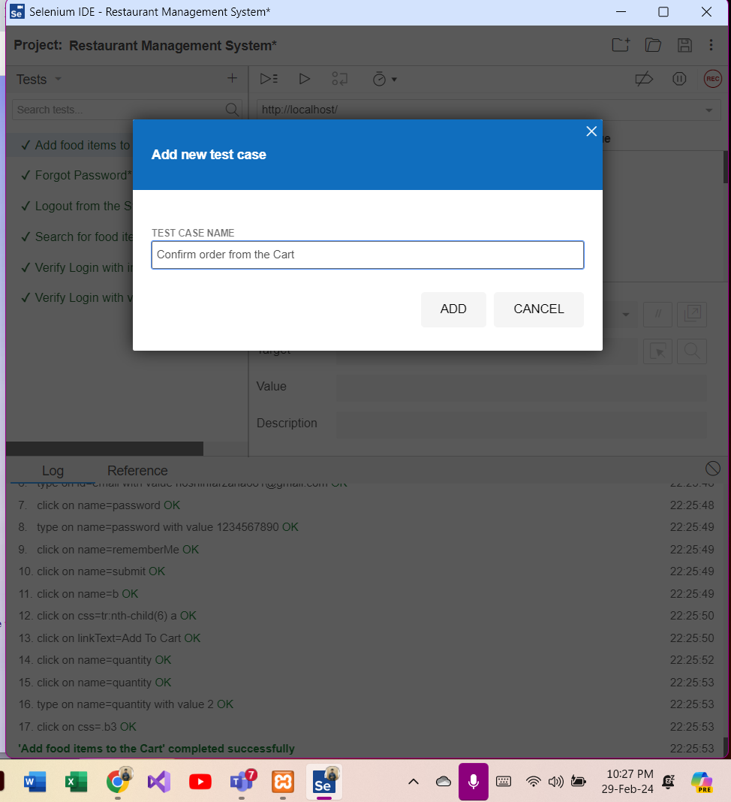

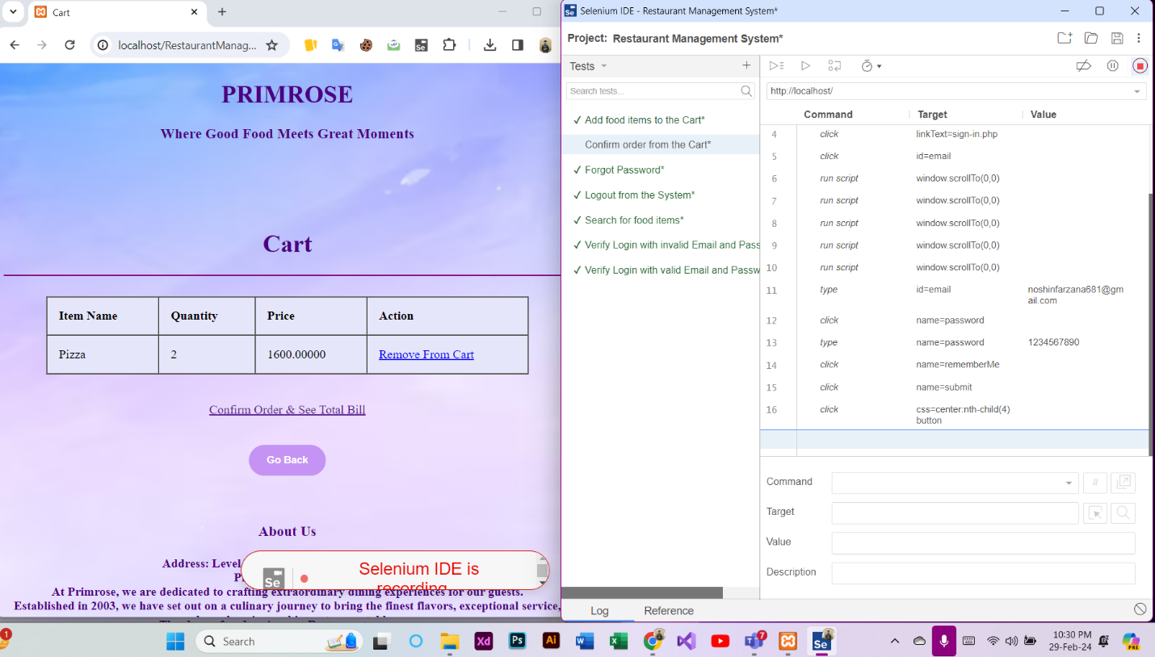

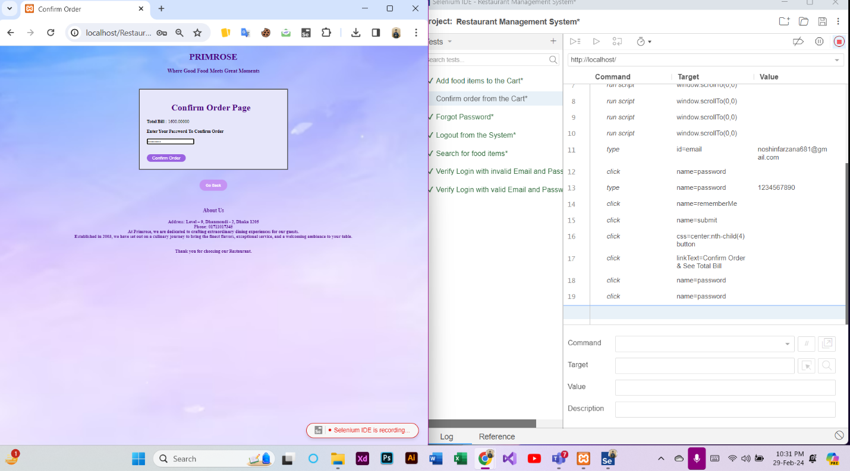

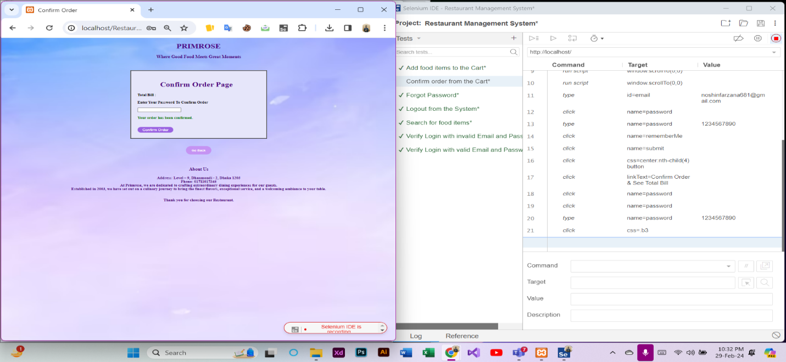

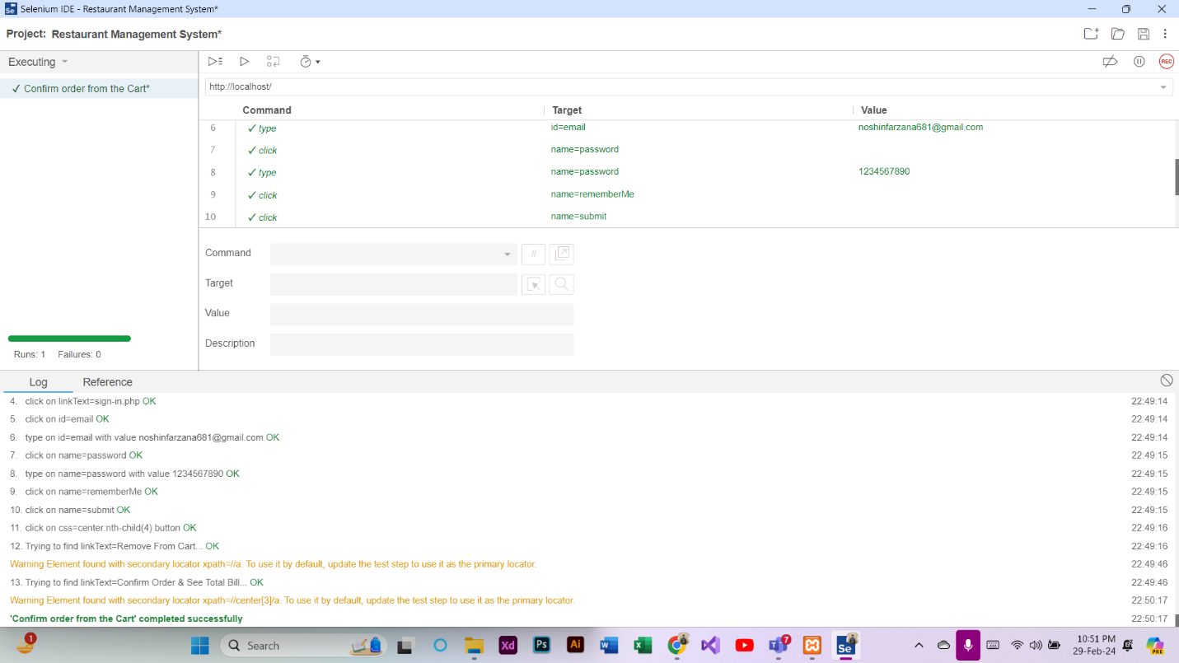

**Test Case 10: Notification of Order & Delivery Man Information (Customer)**

At first, a new test case named “Notification of Order & Delivery Man Information” was added in the Selenium IDE. Then, REC button was clicked to provide the URL of the project and record the activities of notification. After that, the Notification of Order & Delivery Man Information procedure was completed through the website. Finally, the recording was stopped and the test case was run successfully.

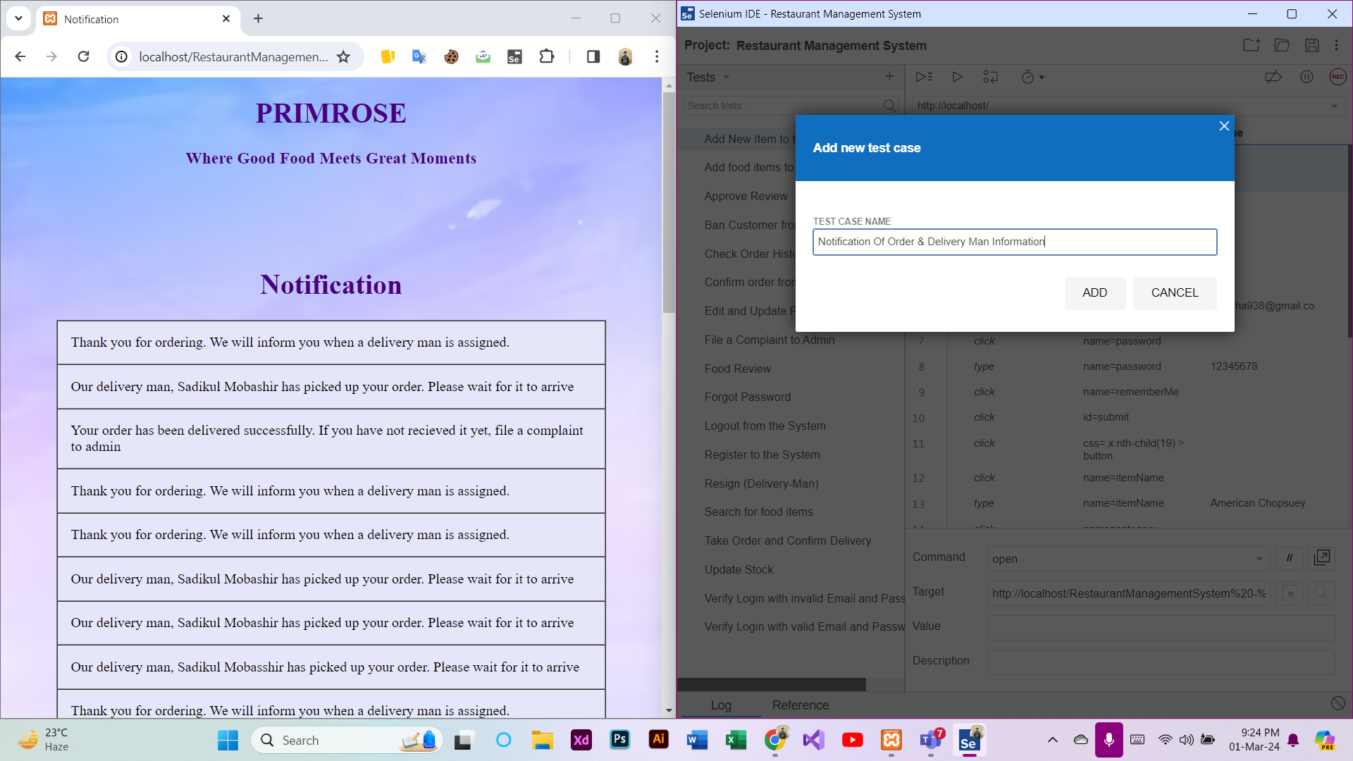

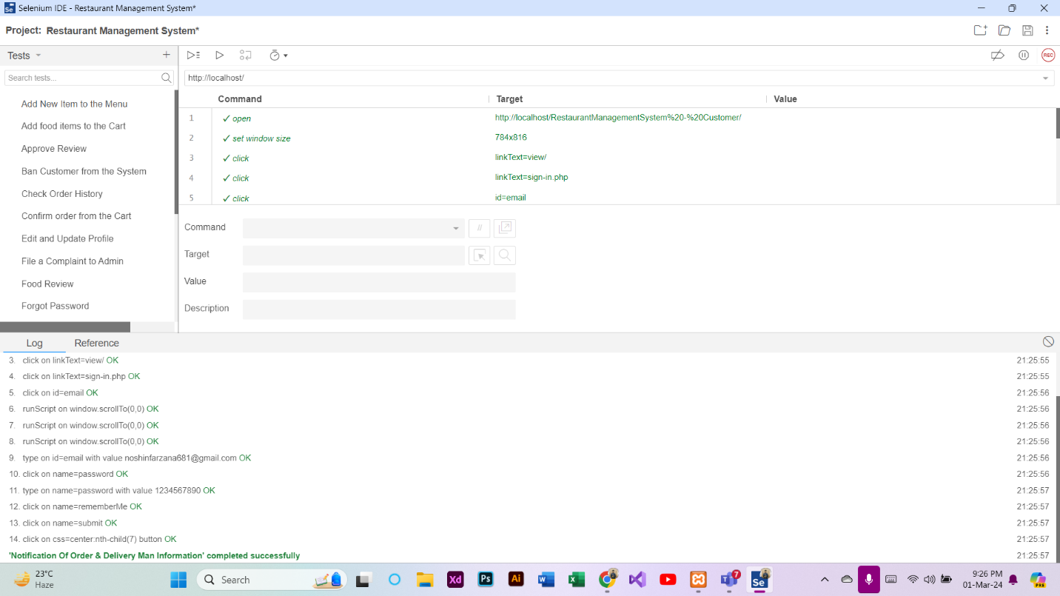

**Test Case 11: Take Order and Confirm Delivery (Delivery Man)**

At first, a new test case named “Take Order and Confirm Delivery” was added in the Selenium IDE. Then, REC button was clicked to provide the URL of the project and record the activities of order taking and delivery. After that, the Take Order and Confirm Delivery procedure was completed through the website. Finally, the recording was stopped and the test case was run successfully.

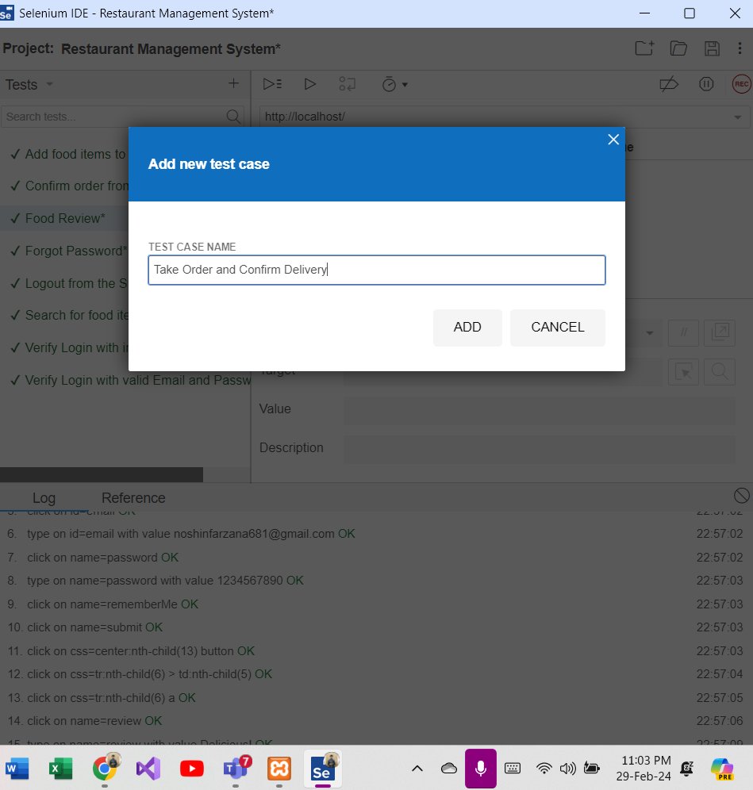

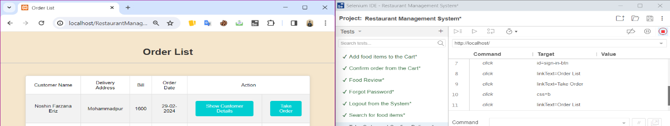

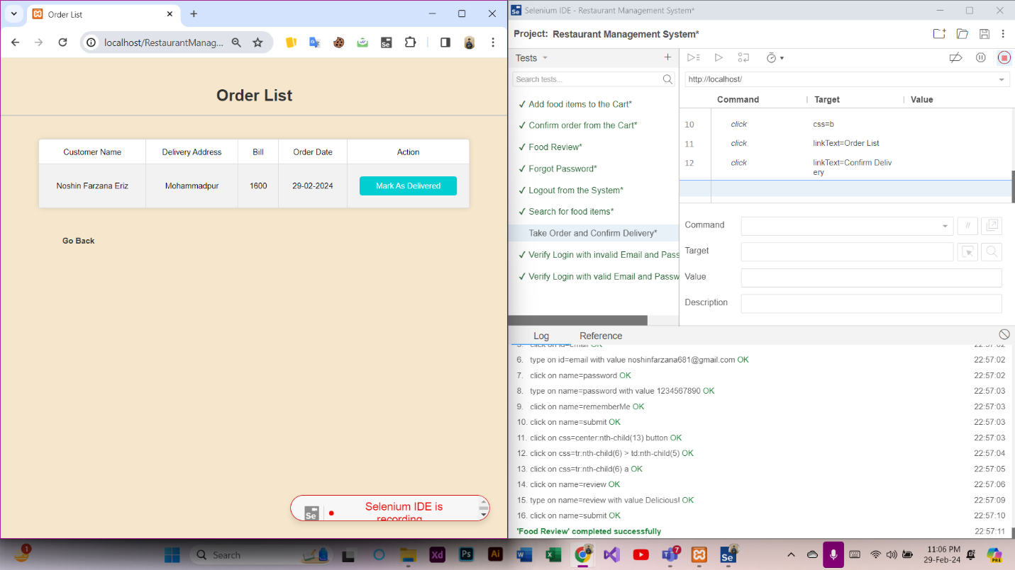

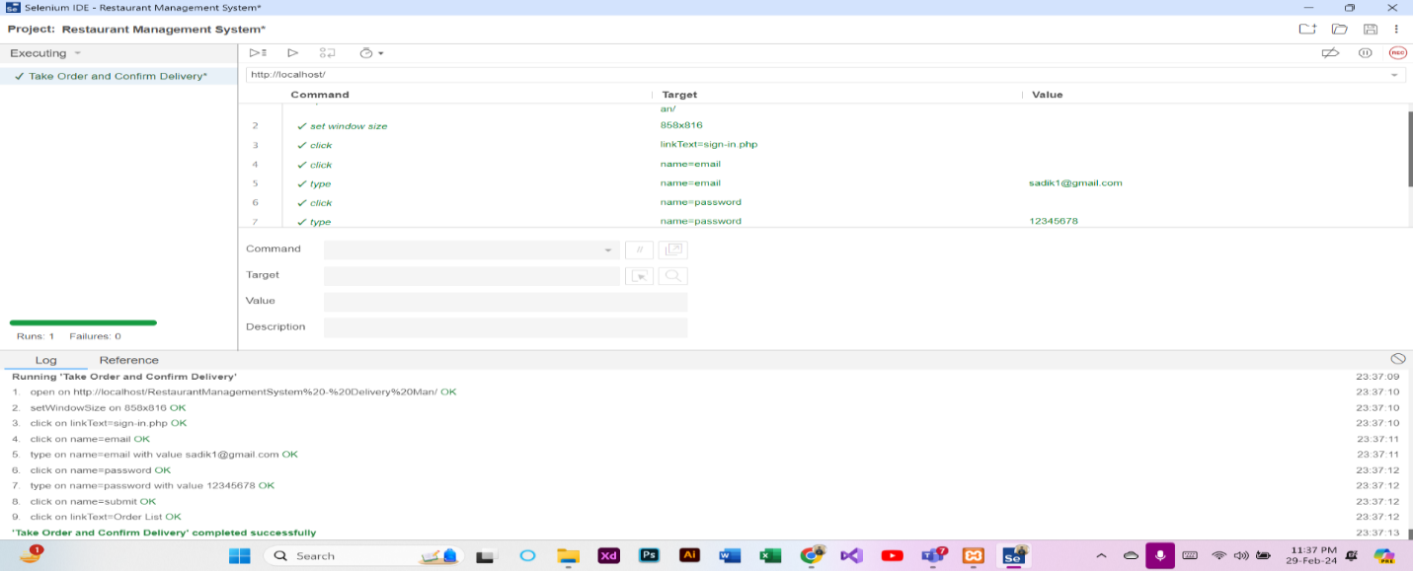

**Test Case 12: Food Review (Customer)**

At first, a new test case named “Food Review” was added in the Selenium IDE. Then, REC button was clicked to provide the URL of the project and record the activities of posting reviews. After that, the Food Review procedure was completed through the website. Finally, the recording was stopped and the test case was run successfully.

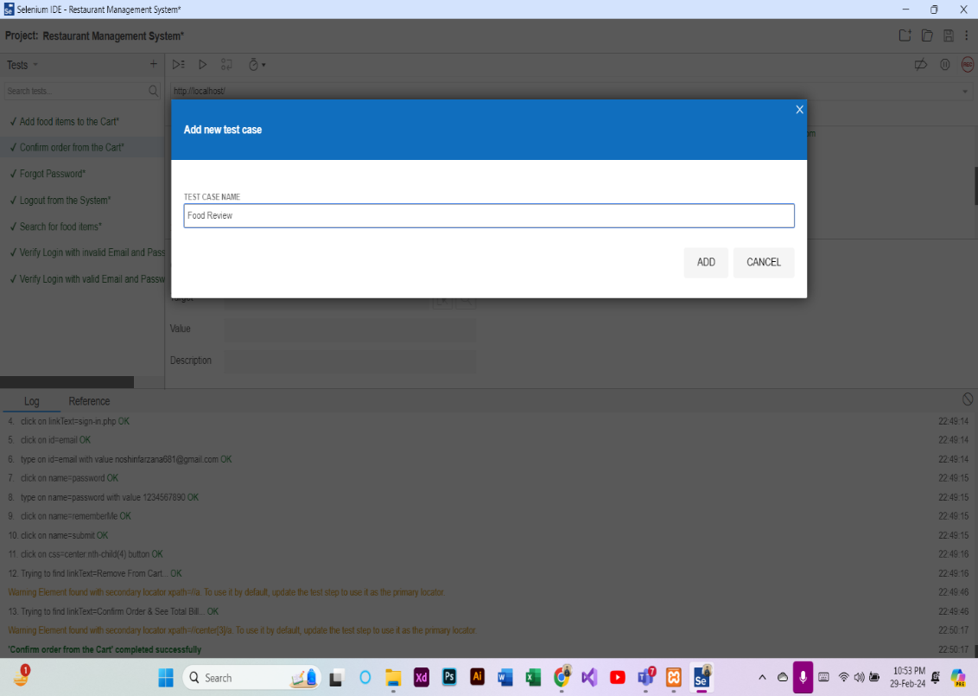

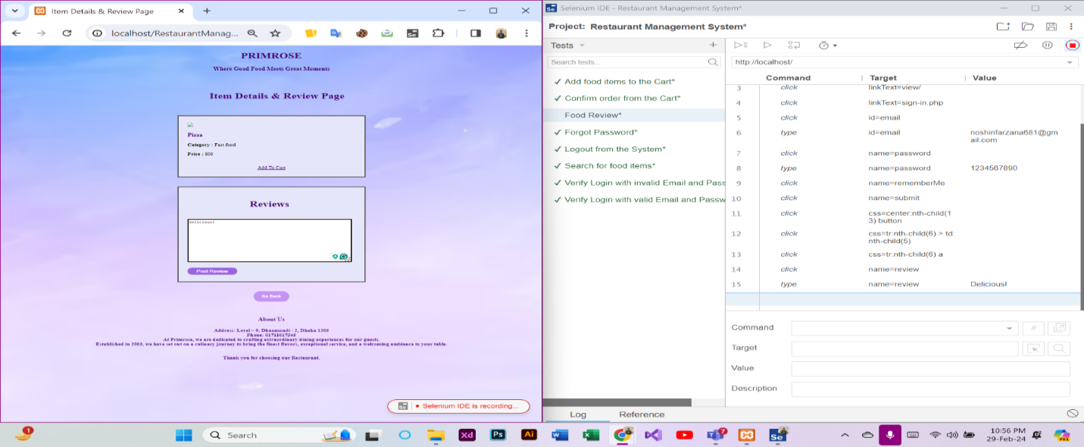

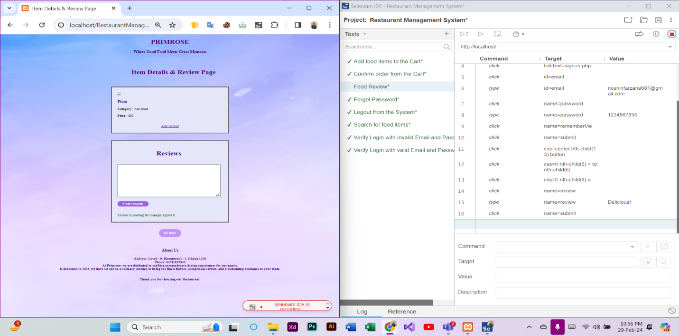

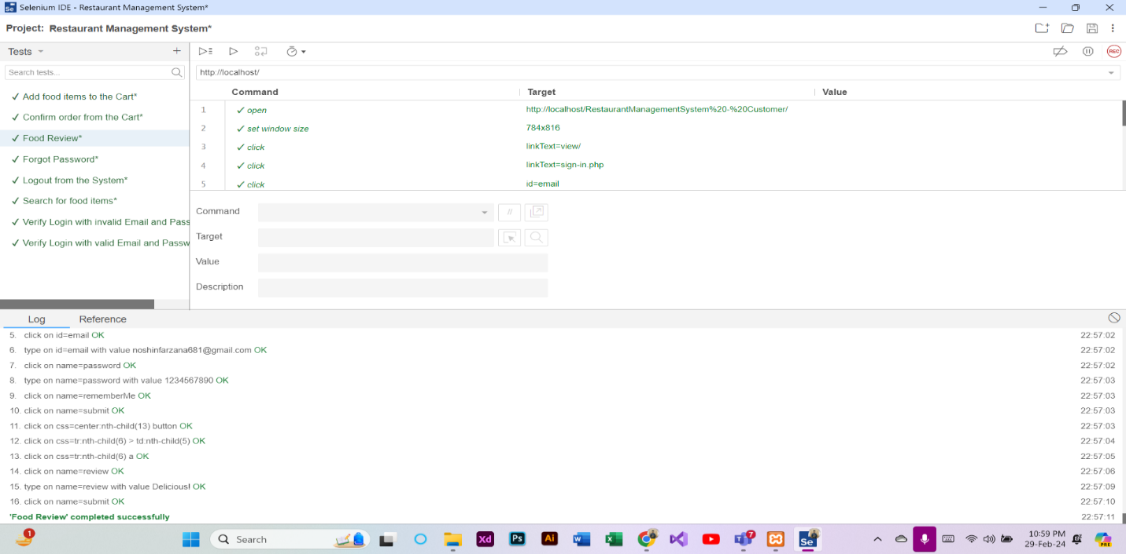

**Test Case 13: Approve Review (Manager)**

At first, a new test case named “Approve Review” was added in the Selenium IDE. Then, REC button was clicked to provide the URL of the project and record the activities of approving review. After that, the Approve Review procedure was completed through the website. Finally, the recording was stopped and the test case was run successfully.

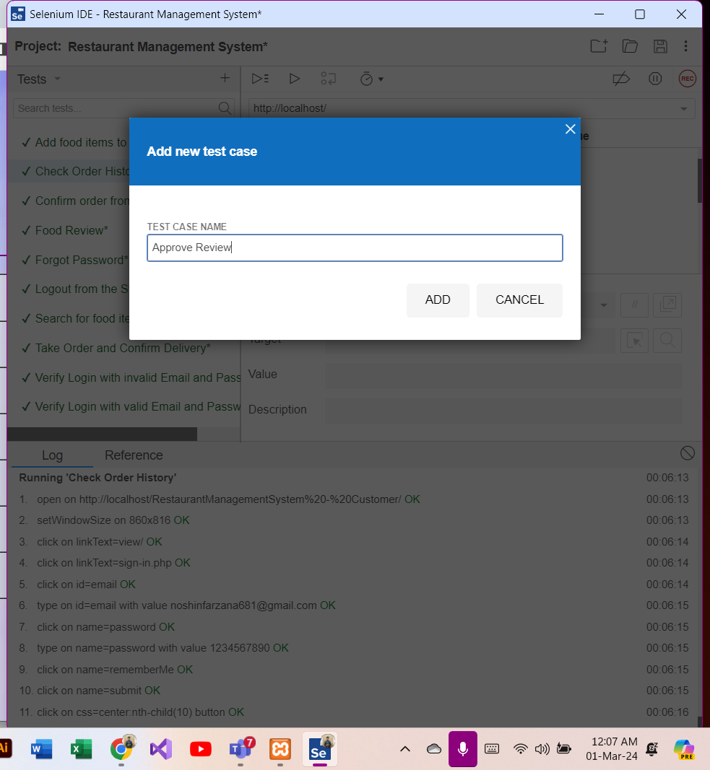

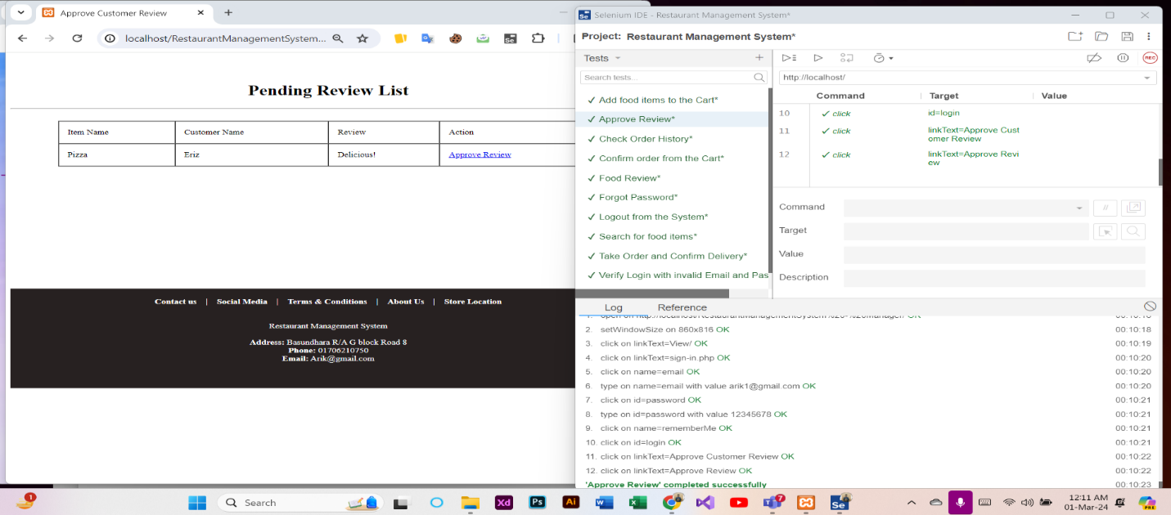

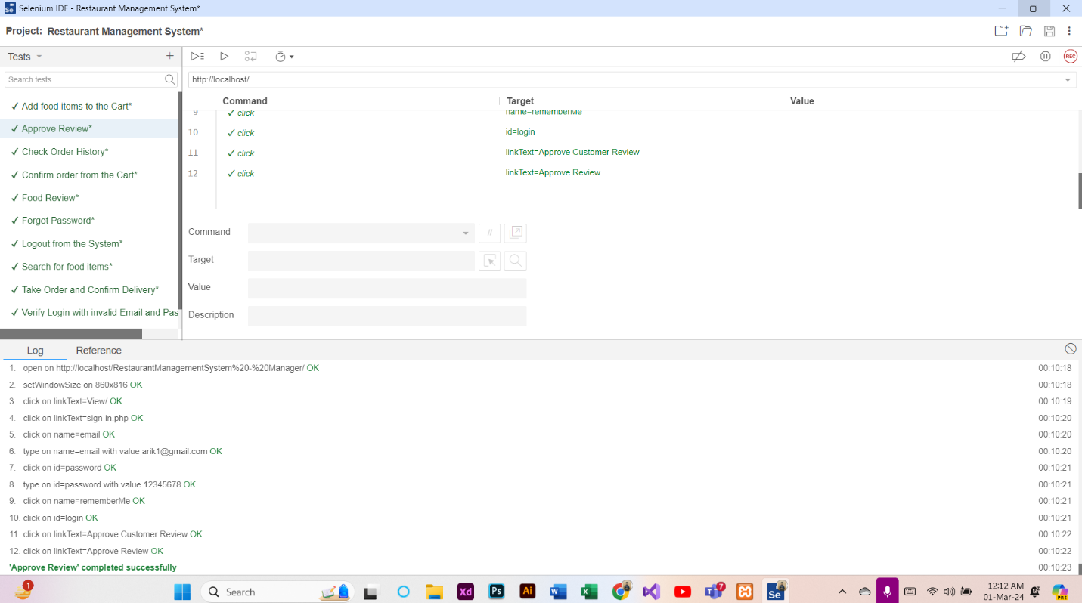

**Test Case 14: Check Order History (Customer)**

At first, a new test case named “Check Order History” was added in the Selenium IDE. Then, REC button was clicked to provide the URL of the project and record the activities of checking order history. After that, the Check Order History procedure was completed through the website. Finally, the recording was stopped and the test case was run successfully.

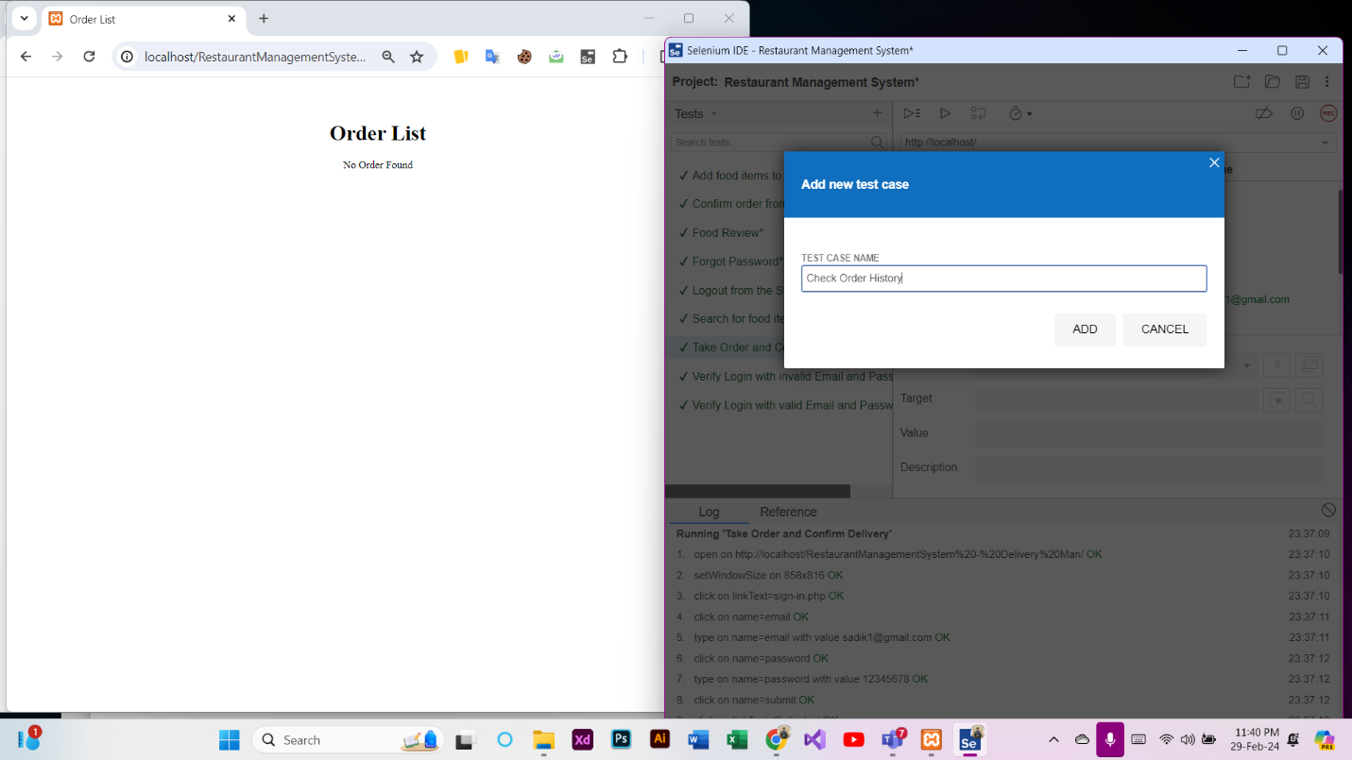

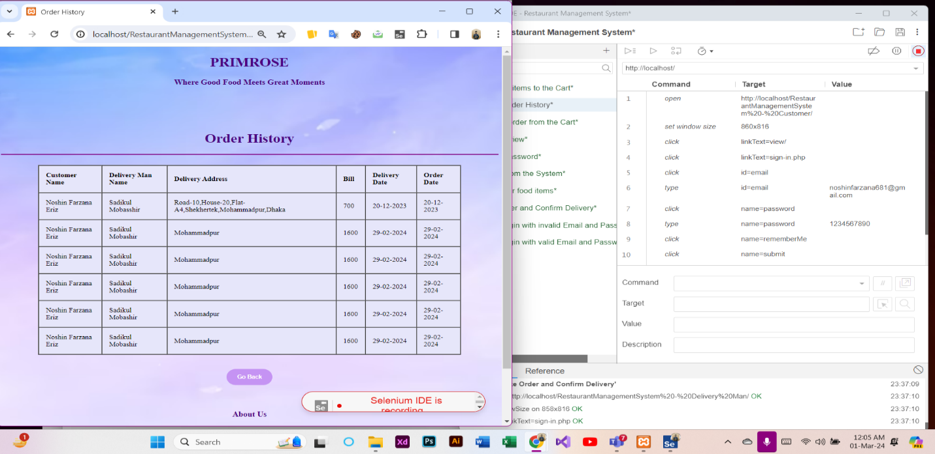

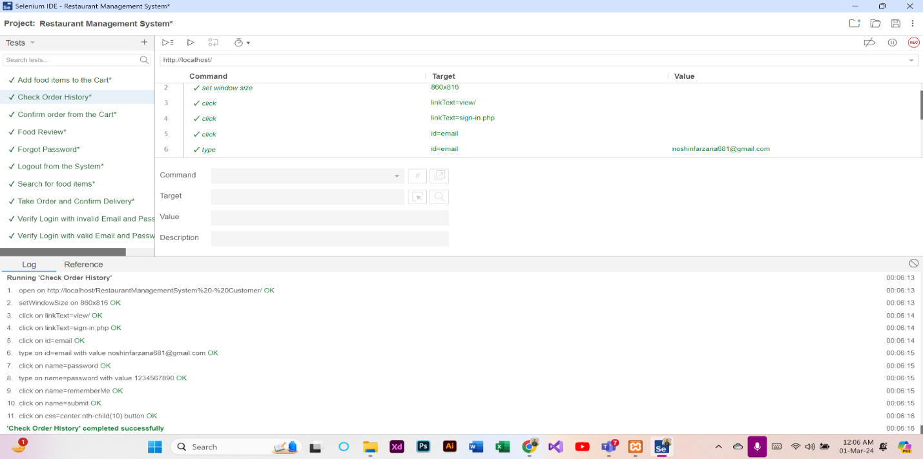

**Test Case 15: File a Complaint to Admin (Customer)**

At first, a new test case named “File a Complaint to Admin” was added in the Selenium IDE. Then, REC button was clicked to provide the URL of the project and record the activities of filing complaint. After that, the File a Complaint to Admin procedure was completed through the website. Finally, the recording was stopped and the test case was run successfully.

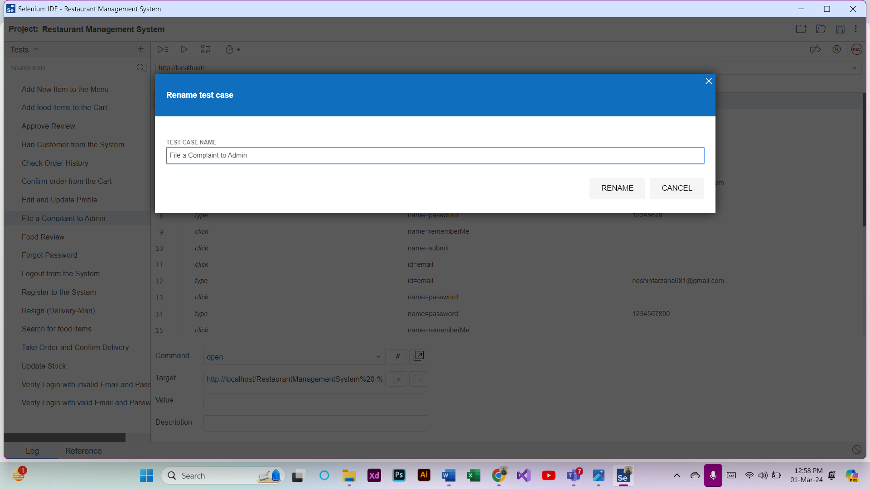

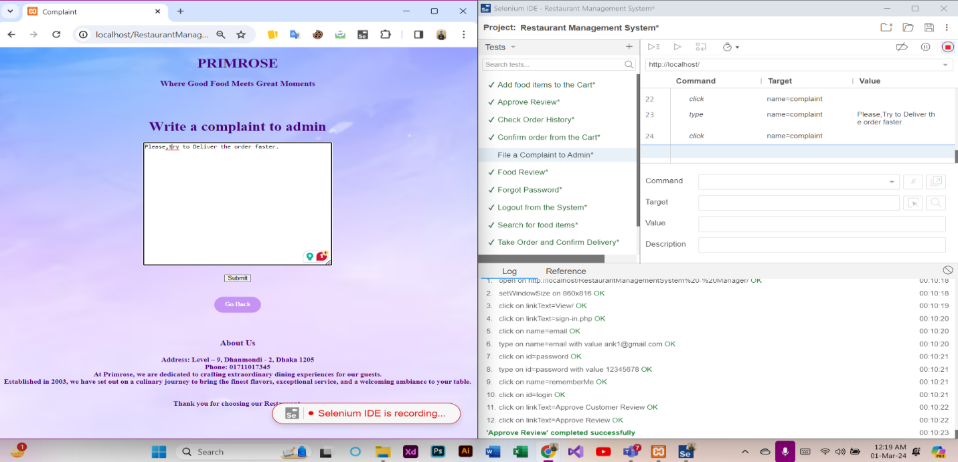

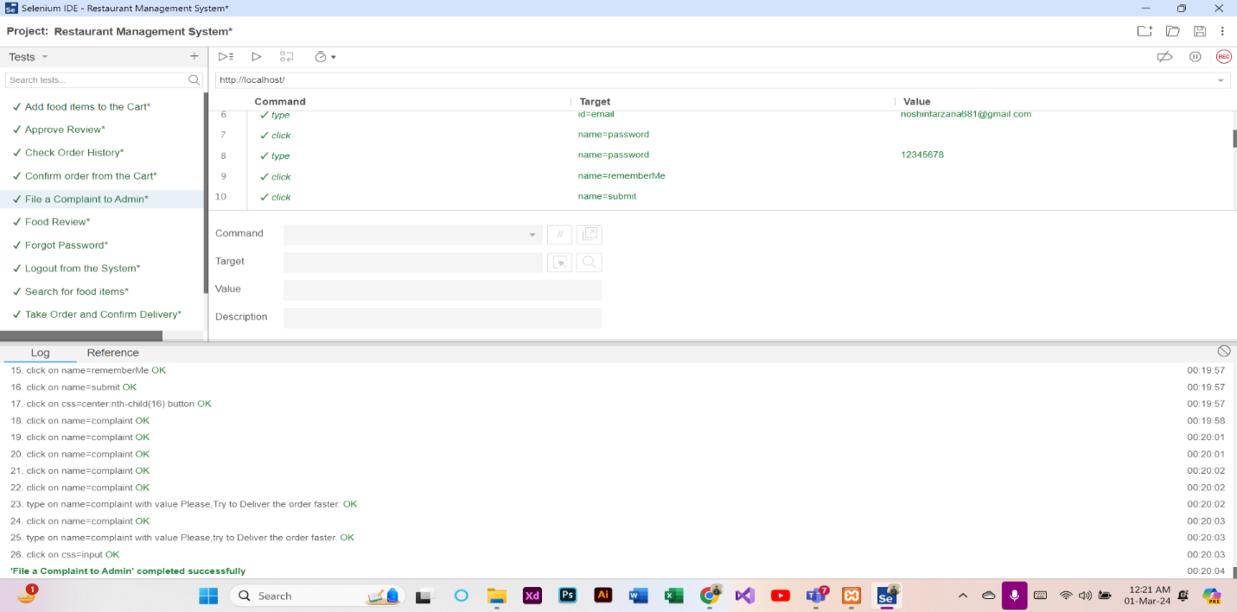

**Test Case 16: Add New Item to the Menu (Admin)**

At first, a new test case named “Add New Item to the Menu” was added in the Selenium IDE. Then, REC button was clicked to provide the URL of the project and record the activities of adding items. After that, the Add New Item to the Menu procedure was completed through the website. Finally, the recording was stopped and the test case was run successfully.

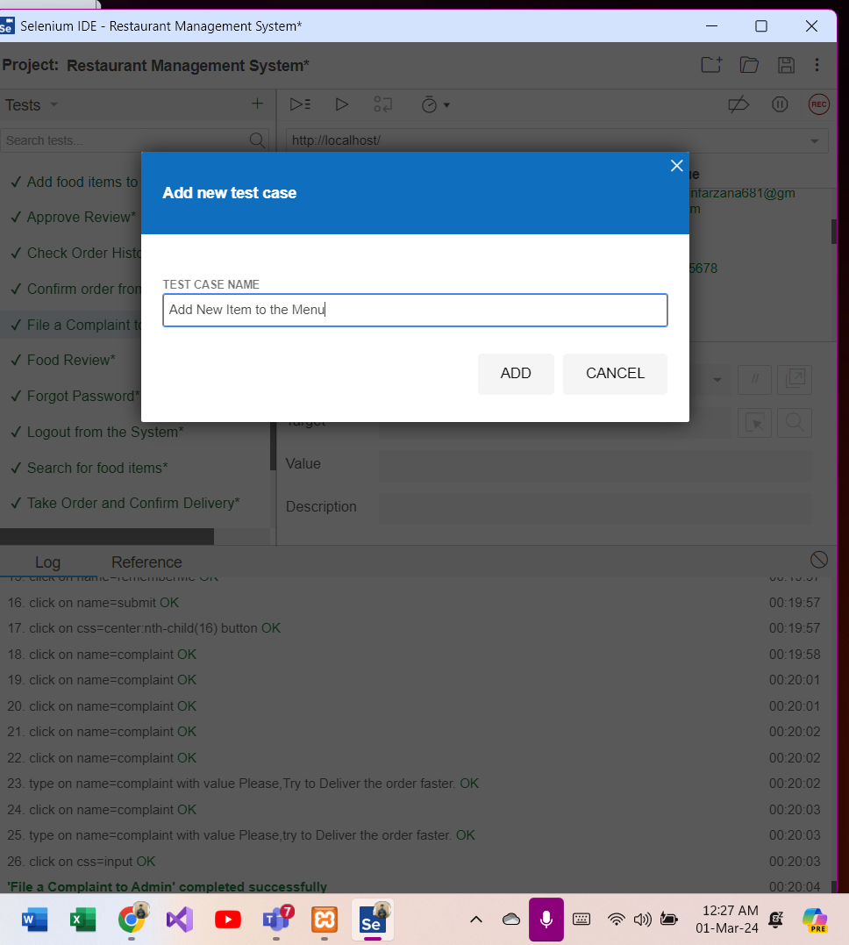

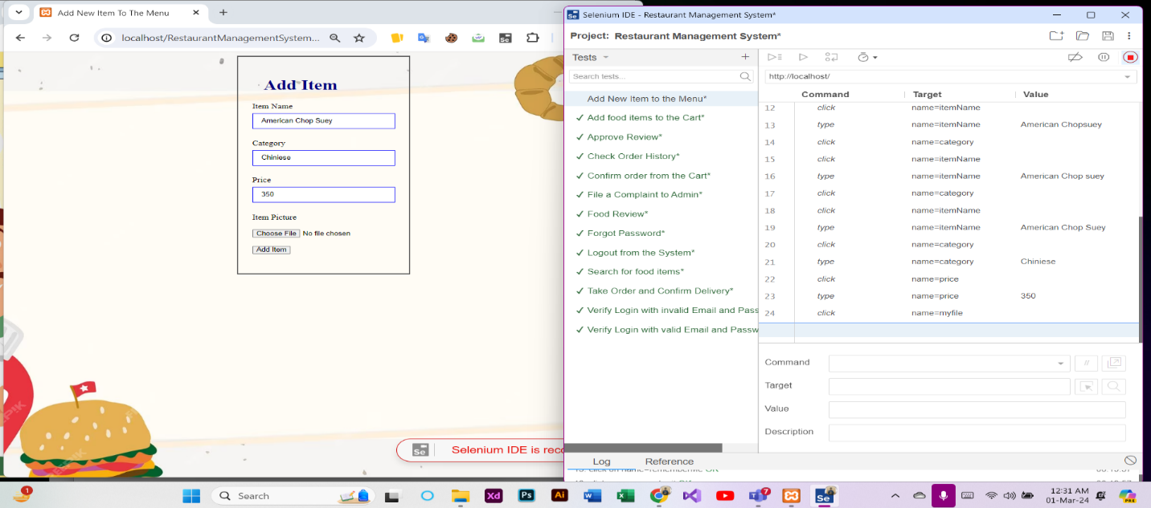

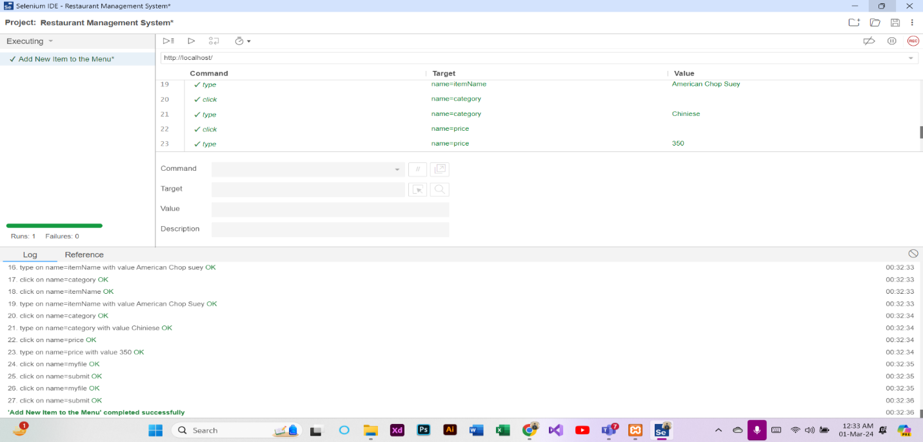

**Test Case 17: Update Stock (Manager)**

At first, a new test case named “Update Stock” was added in the Selenium IDE. Then, REC button was clicked to provide the URL of the project and record the activities of updating stock. After that, the Update Stock procedure was completed through the website. Finally, the recording was stopped and the test case was run successfully.

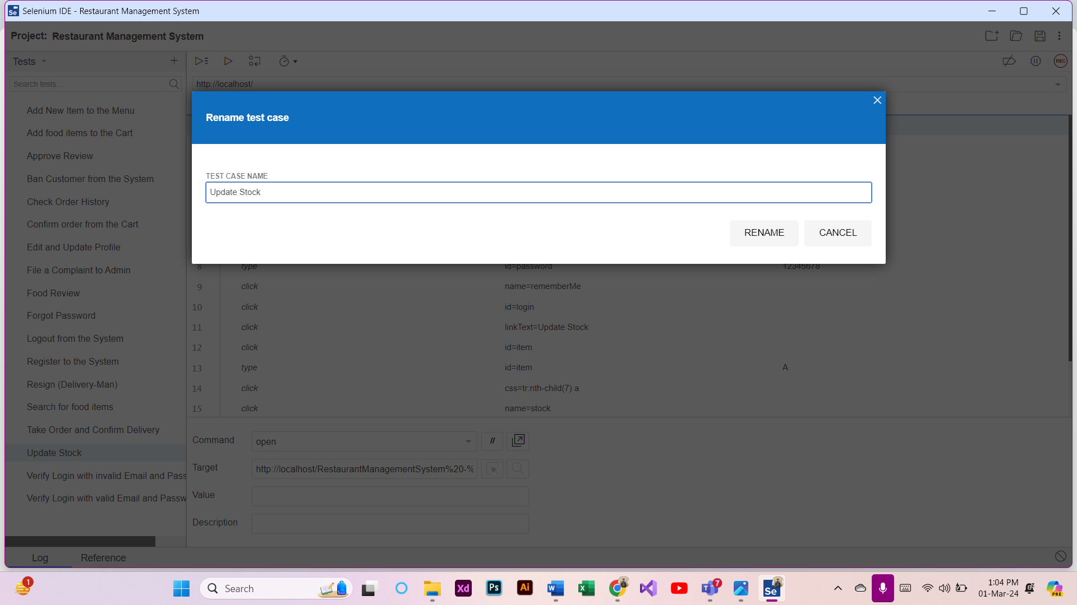

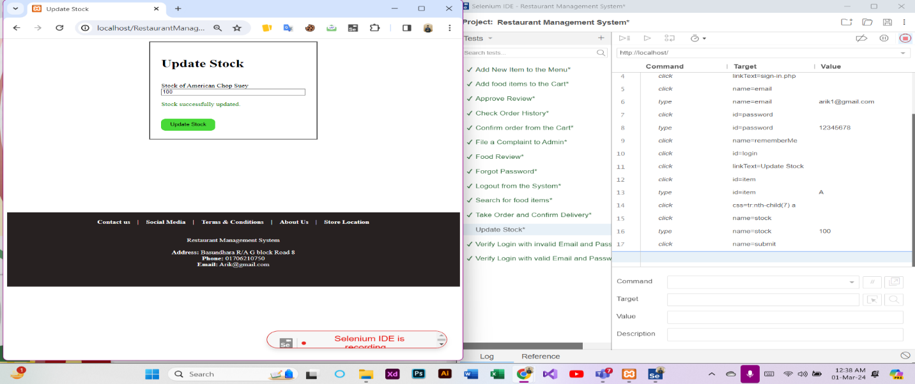

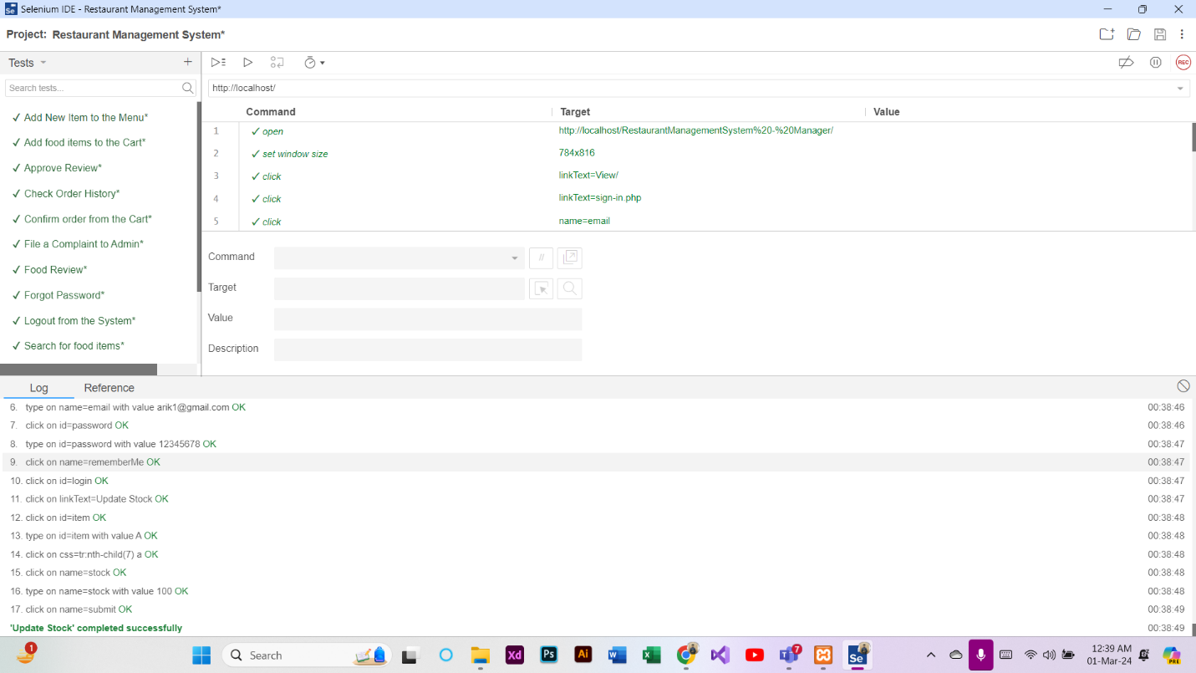

**Test Case 18: See Overview of Total Revenue (Manager)**

At first, a new test case named “See Overview of Total Revenue” was added in the Selenium IDE. Then, REC button was clicked to provide the URL of the project and record the activities of overview. After that, the Overview of Total Revenue procedure was completed through the website. Finally, the recording was stopped and the test case was run successfully.

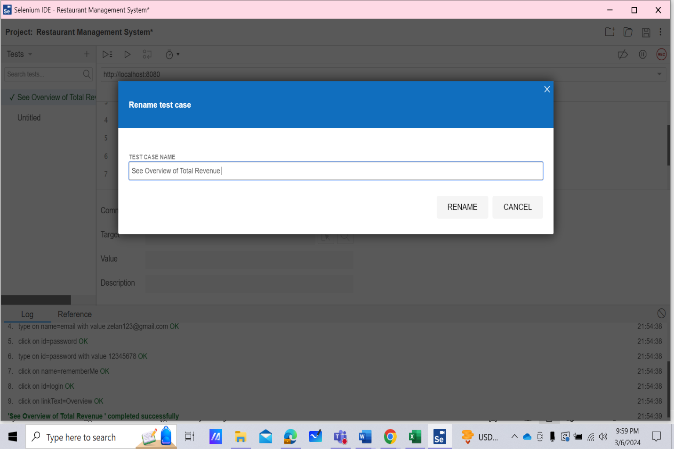

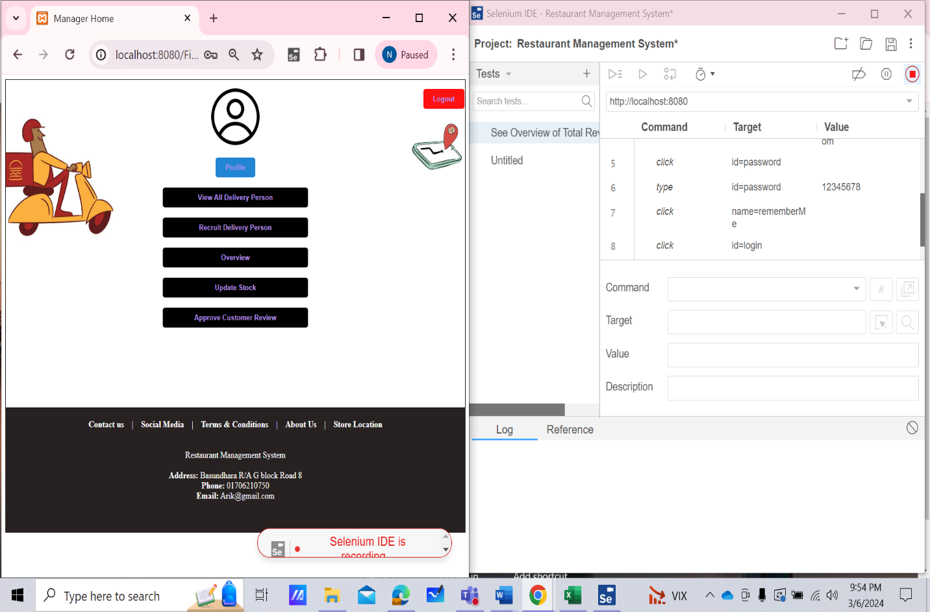

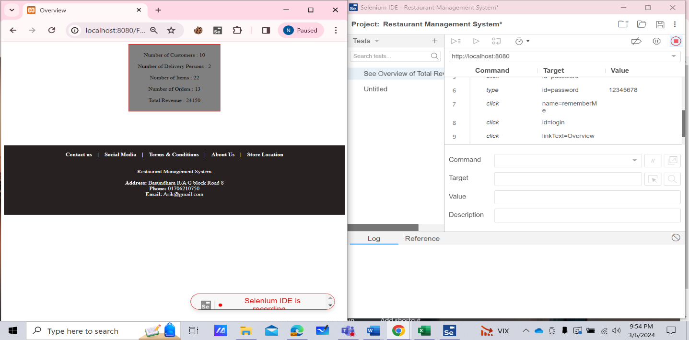

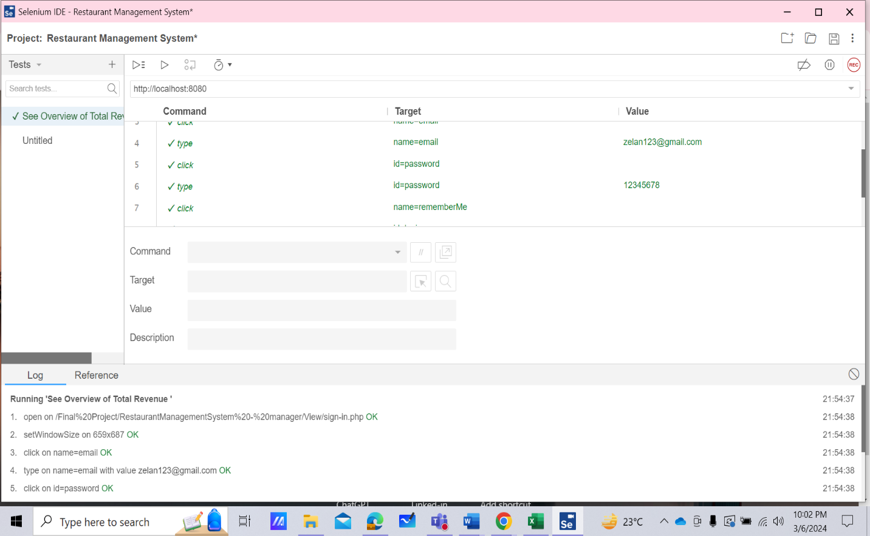

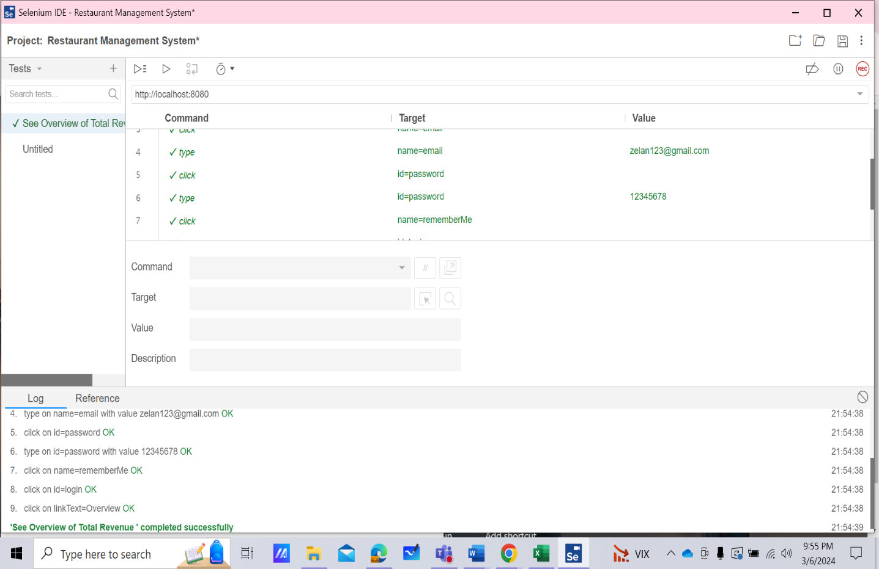

**Test Case 19: Ban Customer from the System (Admin)**

At first, a new test case named “Ban Customer from the System” was added in the Selenium IDE. Then, REC button was clicked to provide the URL of the project and record the activities of ban customer. After that, the Ban Customer from the System procedure was completed through the website. Finally, the recording was stopped and the test case was run successfully.

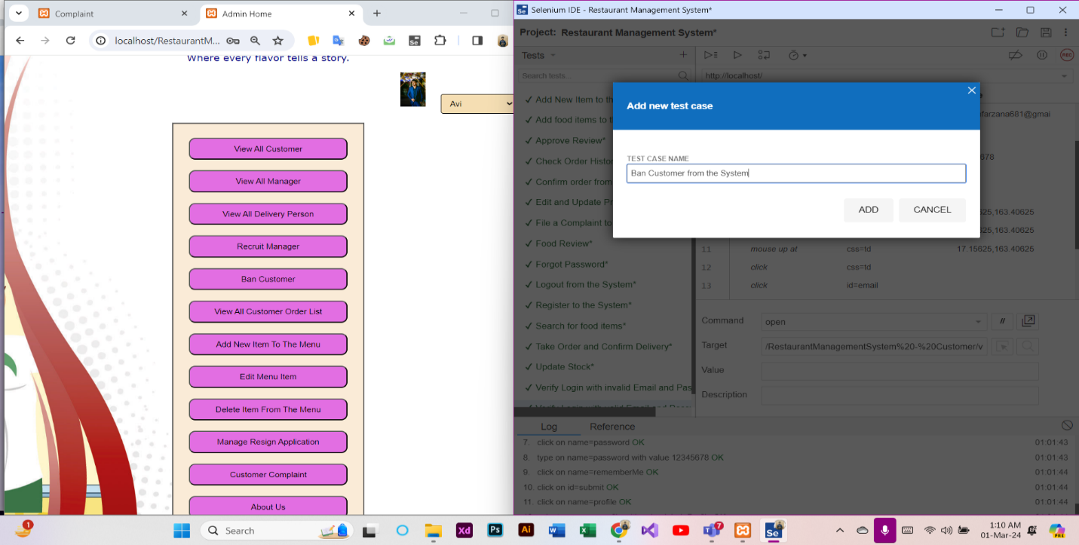

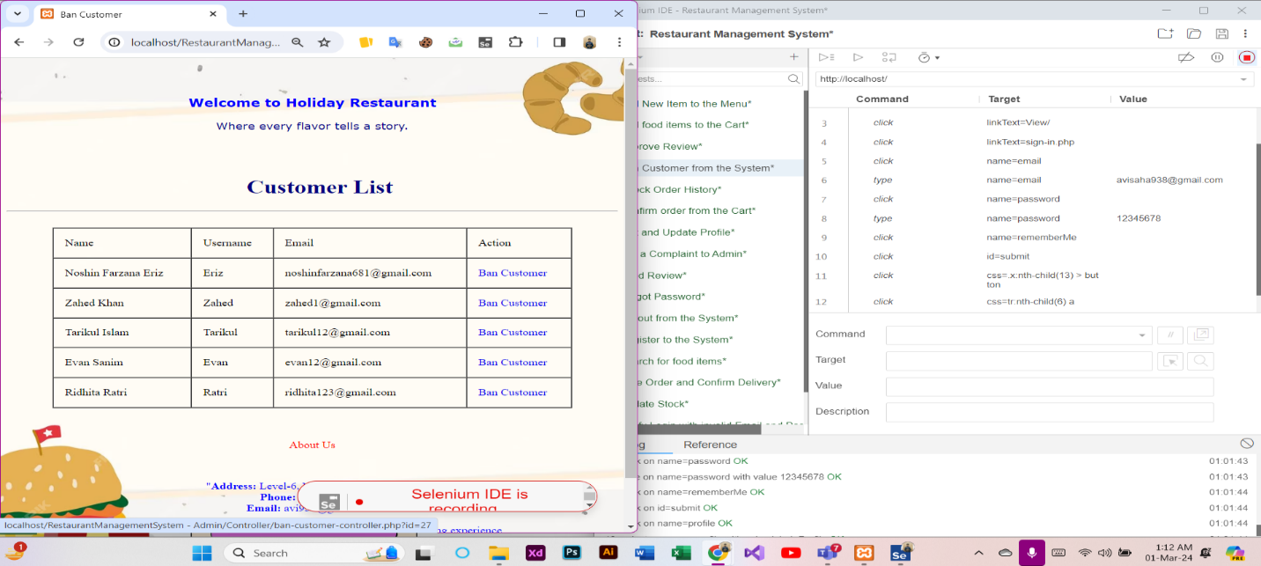

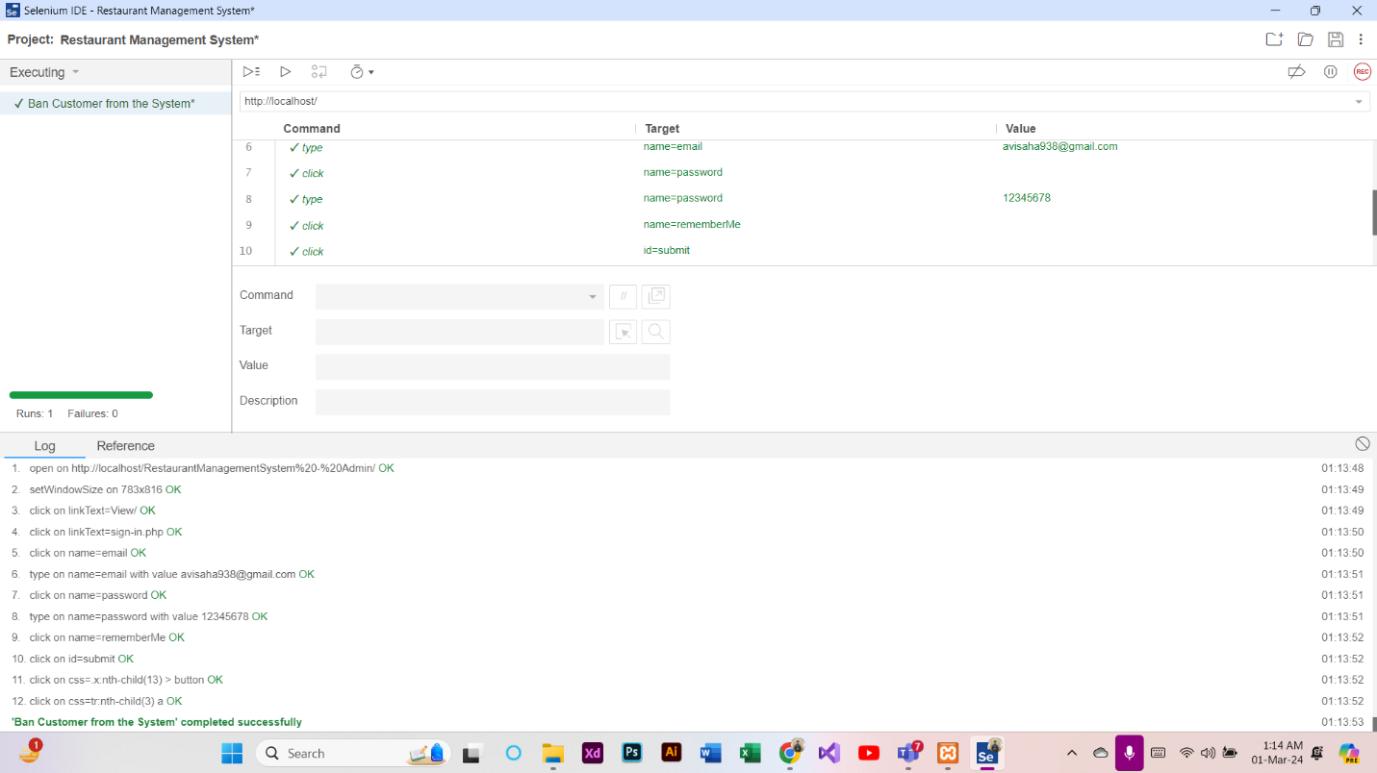

**Test Case 20: Recruit Manager to the System (Admin)**

At first, a new test case named “Recruit Manager to the System” was added in the Selenium IDE. Then, REC button was clicked to provide the URL of the project and record the activities of recruiting. After that, the Recruit Manager to the System procedure was completed through the website. Finally, the recording was stopped and the test case was run successfully.

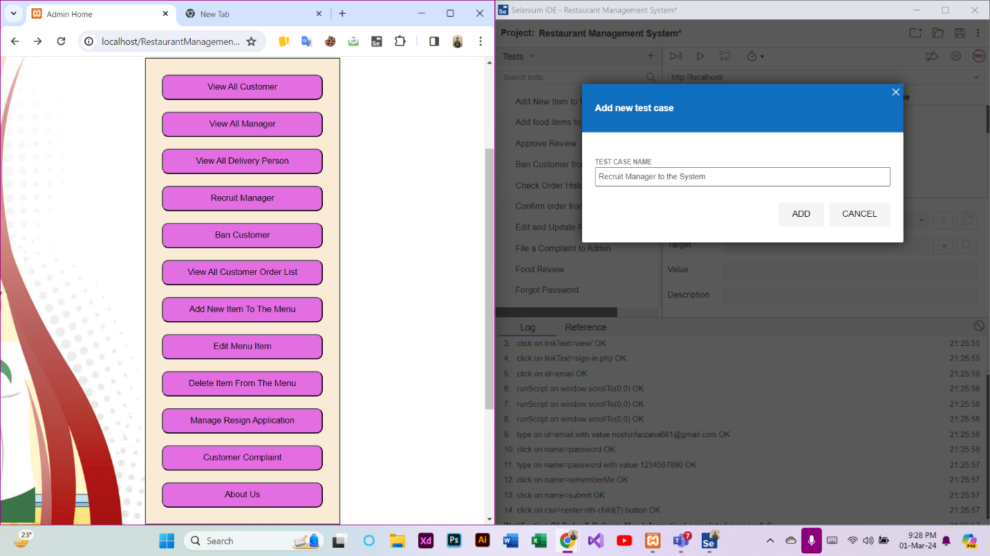

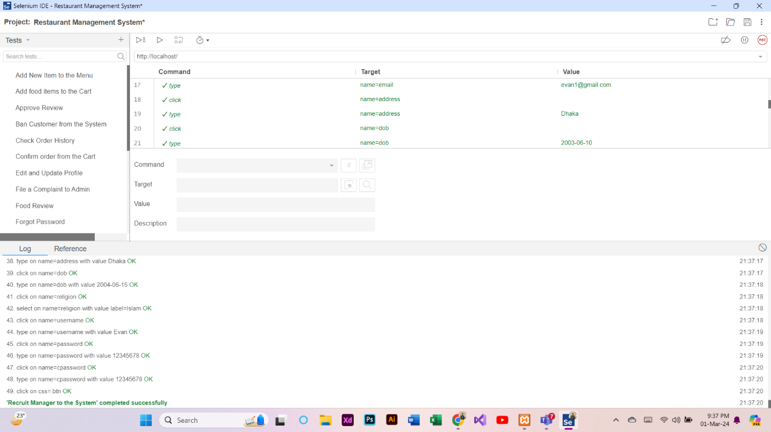

**Test Case 21: Resign (Delivery Man)**

At first, a new test case named “Resign (Delivery Man)” was added in the Selenium IDE. Then, REC button was clicked to provide the URL of the project and record the activities of resigning. After that, the Resign procedure was completed through the website. Finally, the recording was stopped and the test case was run successfully.

